UNIVERSITATEA TEHNICĂ “GHEORGHE ASACHI” DIN IAȘI

FACULTATEA DE MECANICĂ

DIPLOMA PROJECT

Thesis Supervisor:

S.L.DR.ING. Agape Iulian

Graduate:

Risca George - Arthur

Year 2020-2021



UNIVERSITATEA TEHNICĂ “GHEORGHE ASACHI” DIN IAȘI

FACULTATEA DE MECANICĂ

DIPLOMA PROJECT

Conceptual – Constructive Aspects of an Electric Motorcycle

Thesis Supervisor:

S.L.DR.ING. Agape Iulian

Graduate:

Risca George - Arthur

Year 2020-2021

**Table of Contents**

1.General Components of an Electric Vehicle 6

1.1 Electric Motors 6

1.1.1 Brushed DC Motor 6

1.1.2 Brushless DC Motor (BLDC) 6

1.1.3 Permanent Magnet Synchronous Motor (PMSM)) 8

1.1.4 Three Phase AC (alternating current) Induction Motors 8

1.1.5 Switched Reluctance Motors (SRM) 9

1.2 Batteries used in EV systems 9

1.2.1 Lead-Acid Batteries 9

1.2.2 Nickel-Metal Hydride Batteries 9

1.2.3 Lithium-Ion Batteries 10

1.3 Motor Controller 10

1.4 Accessories of Electric Vehicle Systems 11

1.4.1 Throttle 11

1.4.2 Electric Brake (ebrake) 11

1.4.3 Display 12

1.4.4 Hall Sensors 12

1.4.4 Accesorii utilizate de controller-ul meu 12

2.Considerations before construction 13

2.1 Starting Components 13

2.1.1 72V 3000W BLDC Motor Kit 13

2.1.2 Battery Pack 13

2.1.3 Donor Vehicle 14

2.2 Purchasing List 15

2.3 Frames 15

2.3.1 Materials 15

2.3.2 Frame Types 16

2.4 Construction Plan 19

3. CAD Modeling Process 19

3.1 Prototype Model 19

3.2 Assisted 3D Modeling 20

3.2.1 Photogammetry 20

3.2.2 3D Scanning 21

3.3 Modeling my components 23

3.3.1 Controller 23

3.3.2 Suspension (Front fork & Rear shock absorber) 23

3.3.3 Wheels (front & rear with sprocket) 24

3.3.4 Motor 24

3.3.5 Battery 25

3.4 motorcycle Assembly 25

3.5 Frame 27

3.6 Stress Analysis of the Frame 27

4. Battery Build 30

4.1 Lithium-ion batteries 30

4.1.1 Characteristics of lithium ion batteries 30

4.1.2 How energy is stored in lithium-ion batteries 30

4.1.3 How do lithium batteries compare with lead-acid batteries 31

4.1.4 Criteria for choosing a lithium ion electric battery 31

4.2 How to build a lithium ion battery 32

4.2.1 Series connections 35

4.2.2 Parallel connections 36

4.2.3 My battery configuration 37

4.2.4 Battery management system (BMS) 41

4.3 Construction process 43

5. Frame Build 48

5.1 Carbon Fiber 48

5.1.1 Epoxy 48

5.2 Carbon Fiber Process 48

5.2.1 Molding 48

5.2.2 Vacuum Bagging 49

5.2.3 Compression Molding 49

5.3 Building the Frame 49

6. Testing 55

6.1 Reinforcing the Frame 55

6.2 Total Weight 58

7. Conclusion 58

8. Bibliography 62

9. ANNEX 63

**Abstract**

In the past few years, electric vehicles have very quickly gained recognition in the main stream market. They have quickly proven that they aren’t just a passing trend. They are becoming more affordable each year and consumers are becoming more comfortable with the idea of plugging in instead of fueling up. As public attention shifts, we are seeing more and more big manufacturers hop on the EV band wagon.

Many people may be surprised to hear that this isn’t the first time we see this market shift. Electric cars have existed since at least 1834, long before gasoline cars were invented. They reached their peak in 1900 when 38% of all automobiles in the USA were powered by electricity, 40% by steam, and only 22% by gasoline. After Henry Ford revolutionized the production line in 1913, his mass produced Ford Model T made gas powered cars cheaper and more available than ever. By 1935 electric vehicles had all but disappeared from the public eye. Since the beginning, they have faced the same hurdles they do today: limited driving range and a lack of charging infrastructure. As these problems become less and less relevant today, it seems that this time electric vehicles are here to stay.

There are over 10 million electric cars on the road today and this is only expected to grow exponentially. While this doesn’t sound like much, the real attention grabber is the massive market of two - wheeled electric vehicles. By 2023, it is expected that the total number of electric bikes in circulation around the world will reach 300 million.

2 wheel electric vehicles such as bicycles, mopeds, motorcycles, scooters, etc. have piqued my interest lately as an efficient mode of transportation within the city. I wanted to own an electric vehicle for myself, and while I could buy one, I realized that for the same money or cheaper, I could build my own bike while also learning a lot in the process. The amount of accessible information and tutorials are endless. And the simplistic nature of these EV’s make them much easier to approach compared to gasoline powered vehicles.

I not only wanted to create a project focused on learning about the general processes involved in electric vehicles, I also wanted to create something original and personal to me. Instead of just repurposing an old bike frame, I decided to create my own purpose built frame to house our components. After amassing a list of parts for the build, the project consisted of CAD modeling, building the battery pack, building the frame, and finally putting it all together and testing. This project is going to follow me throughout this build process, while concisely showing the relationship between components, and explaining and correcting mistakes I’ve made along the way.

# 1.General Components of an Electric Vehicle

There are a few critical components that make up an electric vehicle. These include the battery, controller, and motor. There are also a number of accessory components that can be added for your use case, such as displays, throttles, PAS sensors, etc. This section will explain the general role of each component to give us a better basis moving on. This project is catered towards electric bikes, although I want to note that many of the same principles are applied to electric cars & motorcycles.

## Electric Motors

The core element of an electric vehicle is the electric motor. Electric motors work by converting electrical energy to mechanical energy in order to create motion. Force is generated within the motor through the interaction between a magnetic field and winding alternating (AC) or (DC) current. There are a few different types of electric motors that can be used, although generally, a good electric motor for automotive applications should have characteristics like high starting torque, high power density, and good efficiency.

### 1.1.1 Brushed DC Motor

Brushed DC motors are one of the most simple and suitable options for Electric vehicles. Today they are found in many appliances, and toys, and they were the most widely used motor for electric vehicles in the early 1900’s. They work by using contact brushes that connect with a commutator to alter current direction. They are inexpensive to produce, simple to control and have excellent torque at low speeds. These traits make it a great option for electric vehicles. The main drawbacks of Brushed DC motors is high maintenance due to brushes and commutators.

**Fig. 1.1.1** Internal diagram of a Brushed DC Motor

### 1.1.2 Brushless DC Motor (BLDC)

Brushless DC motors are similar to DC motors with permanent magnets. They are called brushless because they don’t have the commutator and brush arrangement. They are maintenance free, highly efficient, generate less noise, and have higher power density than brushed dc motors. These motors are currently the most popular option for electric vehicles. There are a few disadvantages, which include that they are hard to control without a specialized regulator and they require low starting loads.

*BLDC motors further have two types:*

Out-runner type BLDC motor (hub motors)

In this type of motor, the rotor is present outside and the stator is inside. They are called hub motors because the motor is directly connected to the hub of the wheel. These do not require external gear systems, although in a few cases, the motor has inbuilt planetary gears. This motor is very popular in 2 wheel electric vehicles like bicycles and scooters because of how non intrusive they are, and leave the frame free to house other components. While not having a gearbox is nice for saving space, it also creates the main big draw back. You don’t have the ability to easily change gearing to increase top speeds or torque.

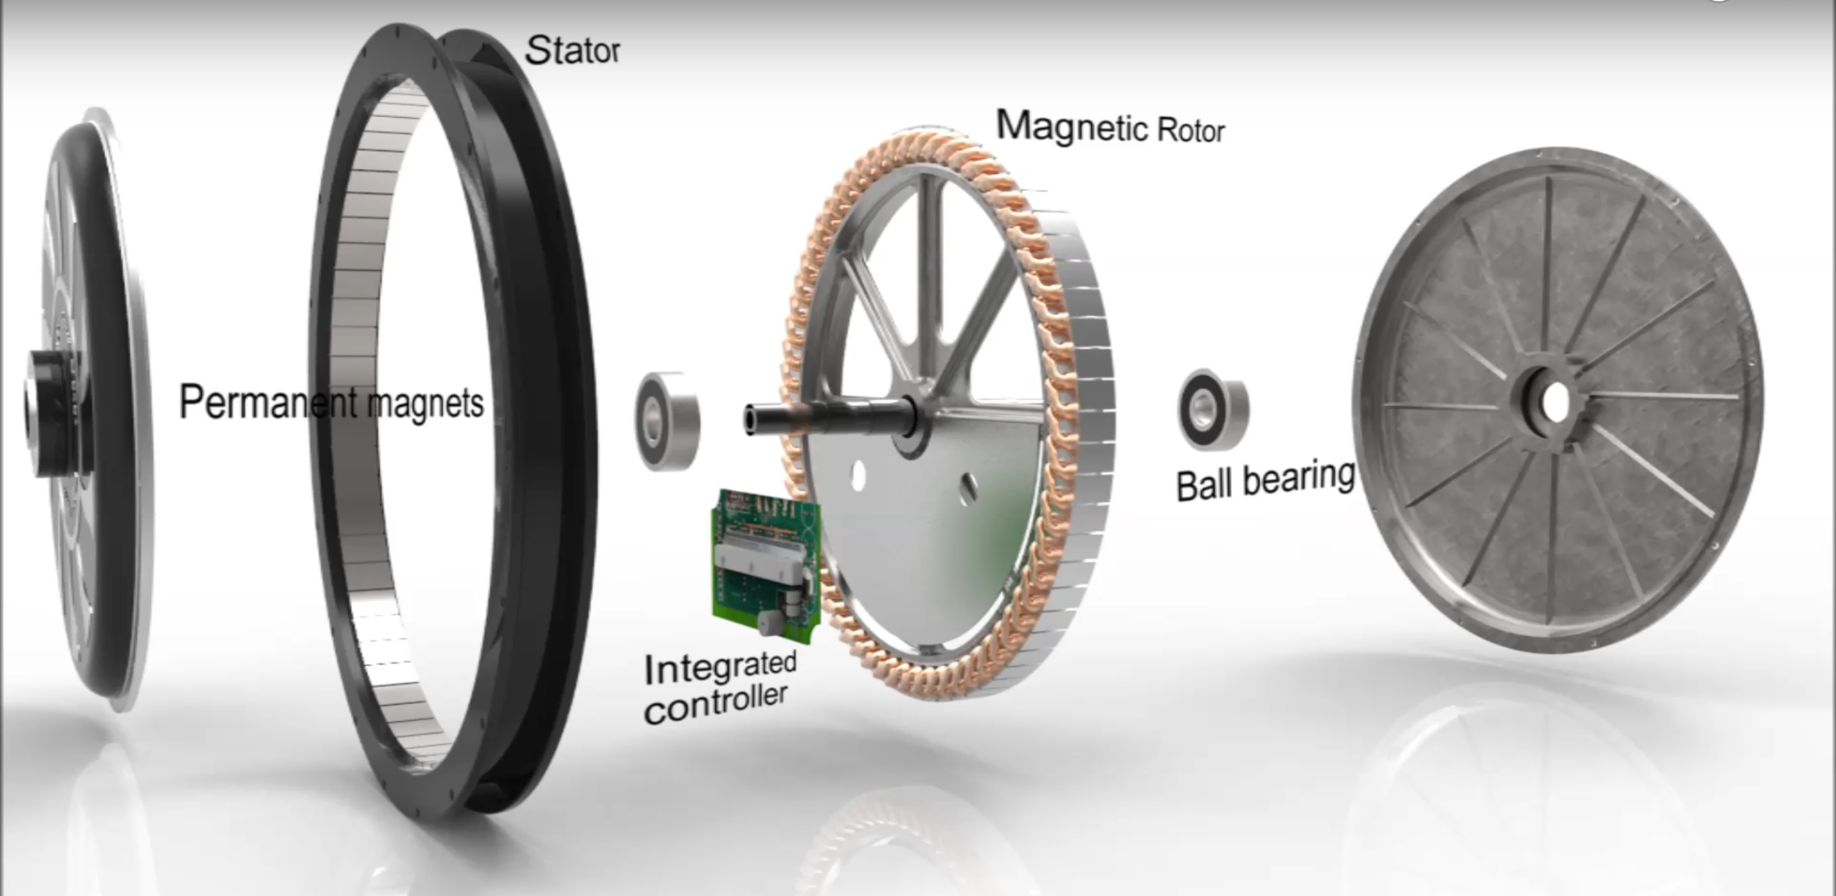**Fig. 1.1.2** Internal components of a Out-runner type BLDC motor (hub motor)

In runner type BLDC motor:

In this type of motor, the rotor is present inside and the stator is outside like conventional motors. These require an external transmission system to transfer power to the wheels and are also bulkier than hub motors because they need to be mounted to the frame. For 2 wheel applications they usually use a chain and sprocket to drive the wheels. For my use case, in runner BLDC motors were cheaper than hub motors with similar power output and also offered higher top speed and flexibility for testing through the ability to change gearing. These are more often used for electric motorcycles and electric cars due to this reason.

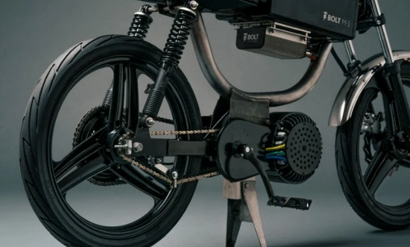**Fig. 1.1.3** In runner BLDC motor mounted on a moped

### 1.1.3 Permanent Magnet Synchronous Motor (PMSM))

Permanent magnet synchronous motors are similar to BLDC motors and have permanent magnets on the rotor. Similar to BLDC motors, they also have traction characteristics like high power density and high efficiency. The difference is that PMSM has sinusoidal back EMF whereas BLDC has trapezoial back EMF. PMSM are available for higher power ratings, making them a good choice for cars and buses. Despite high costs, most automotive manufacturers use PMSM motors for hybrid and electric vehicles. For example, Toyota Prius, Chevrolet Bolt EV, Ford Focus Electric, zero motorcycles S/SR, Nissan Leaf, Hinda Accord, BMW i3, etc use PMSM motor for propulsion.

### 1.1.4 Three Phase AC (alternating current) Induction Motors

An AC motor commonly consists of a stator and a rotor. The stator stays outside which is the stationary part of the motor. It has coils and is supplied with alternating current to produce a rotating magnetic field. The rotor stays inside which is the rotating part of the motor. Induction motors do not have a high starting torque like DC motors, although this can be controlled using various techniques like FOC or f/v methods. By using these methods, the maximum torque is made available from the start, making them a suitable option for EV’s. They are cheap, efficient, low maintenance, and able to withstand rugged environmental conditions. The main drawback is that they require complex inverter circuits and can be difficult to control. Tesla Model S is the best example to prove the high performance capability of induction motors.



**Fig. 1.1.4** Internal diagram of a Three Phase AC motor.

### 1.1.5 Switched Reluctance Motors (SRM)

Switched reluctance motors (SRM) are electric motors that run by reluctance torque. Unlike common BLDC motor types, power is delivered to the windings in the stator rather than the rotor. This greatly simplifies mechanical design as power does not have to be delivered to a moving part, but it complicates the electrical design as some sort of switching system needs to be used to deliver power to the different windings. Electronic devices can precisely time the switching of currents, facilitating SRM configurations. Benefits include high power density, easy cooling, and suitability for high speed applications. Drawbacks include complexity to control and torque ripple.



**Fig. 1.1.5** internal diagram of a SRM motor

## Batteries used in EV systems

The battery is the energy source that powers electric vehicles and are typically the most expensive part of an EV system. Most electric vehicles use battery packs, consisting of multiple batteries connected in series and parallel connections in order to achieve the necessary voltage, amperage flow, and capacity. In the early days of EV’s, most batteries were lead acid, nickel cadmium, or NiMH, but modern EV’s are almost exclusively lithium ion.

### 1.2.1 Lead-Acid Batteries

Lead-acid batteries can be designed to be high power and are inexpensive, safe, and reliable. However, low specific energy, poor cold-temperature performance, and short calendar and cycle life impede their use. Advanced high-power lead-acid batteries are being developed, but these batteries are only used in commercially available electric drive vehicles for ancillary loads.

### 1.2.2 Nickel-Metal Hydride Batteries

ANickel-metal hydride batteries, used routinely in computer and medical equipment, offer reasonable specific energy and specific power capabilities. Nickel-metal hydride batteries have a much longer life cycle than lead-acid batteries and are safe and abuse tolerant. These batteries have been widely used in Hybrid EV’s. The main challenge with nickel-metal hydride batteries are their high cost, high self-discharge, heat generation, and need to control hydrogen loss.

### 1.2.3 Lithium-Ion Batteries

Lithium-Ion batteries are currently used in most portable consumer electronics such as cell phones and laptops because of their high energy per unit mass relative to other electrical energy storage systems. They also have a higher power to weight ratio, high energy efficiency, good high temperature performance, and low self-discharge. Most of todays hybrid EV’s and EV’s use lithium-ion batteries, though the exact chemistry often varies from that of consumer electronics batteries. Research and development are ongoing to reduce their relatively high cost, extend their useful life, and address safety concerns in regards to overheating.

## Motor Controller

The motor controller is one of the most important parts to any Electric Vehicle. It is an essential piece of hardware that operates between the batteries and motor allowing control of the electric vehicle’s speed and acceleration.

It serves two critical functions:

* Converts DC voltage of the battery pack into 3 phase alternating current for the motor windings without which the motor could not spin.
* Continuously adjusts the voltage going to the motor, from 0V up to the full battery pack voltage, in response to the user’s throttle signal, pedal sensors, and various current limits.

The ability to control voltage is the most important aspect. Voltage directly correlates to the rpm of our motor, so we need to alter voltage in order to change our speed. For example a motor might only use 10-12V at low speeds, 25V at moderate speeds, and 48V at top speed. If you have a 48V battery pack and ride at 50% throttle, then the motor will see 24V and will perform as it would with a 24V battery at full throttle. While it steps down the voltage going to the motor, it also steps up current by the same ratio. You can have 48V and 10A flowing from the battery to the controller and then 24V and 20A flowing from the controller to the motor.

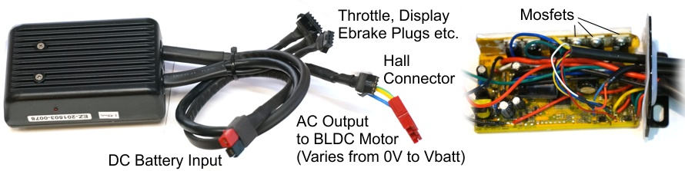 Motor controllers contain power mosfets, large capacitors, and connectors for throttles, brake cutoffs, displays, and more. The controllers circuitboard is often fit inside an aluminum box to protect it’s components from rugged conditions.

**Fig. 1.3** example of a ebike controller

Controllers have a specific voltage range they will work in, and will also have a current limit that defines the maximum amperage they will draw from the battery pack. A small low current controller might be rated for 14 amps, whereas in our case, our controller is rated for 50 amps. When the motor attempts to draw more current than this, the controller will automatically reduce voltage provided to the motor in order to keep the battery current at the limit. You can use a lower amperage rated controller with a more powerful motor, but you will not be able to reach the full capabilities of the motor. If you used a high amperage controller with a low power motor, you can over power the motor outside it’s recommended parameters, possibly causing overheating, reducing lifespan, and damaging internal components. Therefore it’s recommended to have components that are meant to function at similar voltages and current.

## 1.4 Accessories of Electric Vehicle Systems

### 1.4.1 Throttle

A throttle is the most familiar way of allowing the driver to regulate the amount of power they get from the motor. This can be by using a throttle pedal like in electric cars, or a throttle lever or twist grip in 2 wheel cases like in bikes and motorcycles. A throttle gives the rider full control over acceleration at any given time.

Almost all controllers have a throttle input plug, and luckily the throttle signal is very standardized across the industry. Even if the connectors are different, the function is more or less the same. Throttles use hall sensors and a magnet to detect throttle position. They sit at 0.8-0.9V when throttle is off, and rise to 3.6-4V when throttle is applied.



**Fig. 1.4.1** Example of a twist throttle and pedal throttle commonly used in EV systems

### 1.4.2 Electric Brake (ebrake)

An ebrake sensor is an optional device used to tell the controller when you are pressing the brake pedal or levers. There are two reasons for using an ebrake sensor. One is to have a safety cutoff, so that no matter what the motor will shut off when you press on the brake. The second reason is to activate regenerative braking on systems that support regen. That allows you to squeeze the brakes a little bit and have the motor switch from powering the bicycle to providing a smooth and steady braking force, with the braking energy going back into the battery pack. Both mechanical and hydraulic brake levers are readily available these days with an ebrake switch sensor built in. There are also add-on sensors that can be installed onto your existing brakes to provide the same switch signal.

This brake lever has the ebrake sensor built in and will automatically send signal to the controller when you pull the lever.

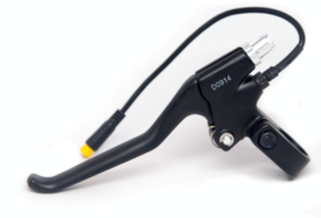

**Fig. 1.4.2** Example of a bycicle brake lever with ebrake sensor

### 1.4.3 Display

Most ebike controllers or electric car controllers include a detailed display or dashboard to see what is going on such as battery level and speed. Unfortunately, displays do not have standardization in function, communication bus, or communication protocol. This means that displays are developed specifically for a certain controller, and it’s difficult to adapt different displays to different controllers. Some ebike controllers now offer bluetooth communication which allows you to use your phone as the main display. In cases such as mine, my controller doesn’t have support for a display and so I needed to use different solutions to display important information such as battery voltage and current speed.

**Fig. 1.4.3** Example of a standard ebike display

### 1.4.4 Hall Sensors

3 phase BLDC motors typically include three hall sensors that indicate the rotational position of the rotor. Some motor controllers can only function when these sensors are present as they use the hall pattern exclusively to time the changing current through the three phase wires. Other more advanced controllers do not use hall sensors and instead do their best to figure out rotor position and phase timing based on cues from the current flow and or voltage on the phase leads. This is called running the motor “sensorless”. Sensorless operation is fairly easy to sustain when a motor is spinning, but when a motor is stationary or moving slowly, it can be challenging to do well. Some controllers use hall sensors only for starting, and switch to sensorless once above a certain speed. When mixing and matching motors and controllers, it’s important to know if your motor has hall sensors or not, since that determines which controllers may or may not be compatible. In my case, my motor does use hall sensors.

### 1.4.4 Accesorii utilizate de controller-ul meu

Controlerul meu are conexiuni pentru blocarea puterii, ebrake, setări de viteză, inversare, accelerație și antifurt. Din păcate, nu există ecran, așa că am avut nevoie să găsesc alte opțiuni

**Fig. 1.4.4** the different connections offered by my controller

# 2.Considerations before construction

## 2.1 Starting Components

As a follow up to our first section, I will go over the specific components I used in this build. This includes motor, controller, batteries, and also the frame our vehicle will be built on.

### 2.1.1 72V 3000W BLDC Motor Kit

Includes 50A controller, ignition, throttle w. F/R & 3 speed settings, and sprocket. This was my first purchase in the build because the battery I build depends on my motor and controller requirements. All of my CAD work will be done in relationship to placement of these components also.

### 2.1.2 Battery Pack

Most of my purchases for this project were made în relation to building the battery pack. These Include:

- 120 Samsung 30Q 18650 batteries

- 240 plastic battery clips

- 100 meters Nickel Strip 0.15x8mm;

- Heat resistant tape

- 120 Insulator rings for 18650 positive terminal

- Battery management system (BMS)

- Charger 84V 3A;

- Spot Welder

- XT90 anti spark connectors

- 10 gauge silicone wire

There will be pictures and in depth explanation of these components later on once I begin building the battery.

### 2.1.3 Donor Vehicle

For this project I decided to use a pre existing moped to build off of. I did this for a few reasons. One is that I already owned this moped which isn’t running, so it is no added cost to my build. The second reason is that this bike has components which already work together. By having wheels with drum brakes, suspension fork, rear shocks, trailing arm, and knowing that all these components fit with eachother, it was able to save me much headache down the line. For example if I bought wheels with disc brakes, I would need to have a fork with compatible mounting for calipers as well as fabricate mounting for the rear brake caliper. It is definitely possible but requires a higher level of product design necessary if making a production vehicle with intent to sell. Since I am making a single motorcycle, using a donor bike is a good way to save time and money.

For my build I used a 1978 JC Penney Pinto. Strangely enough, JC Penney used to have mopeds. The pinto was actually made by the Austrian manufacturer: Kromag, using a Puch E50 engine. It was imported and rebranded on the JC Penney catalog. I was about 10 years old when my dad brought it home. He bought it for $100 from a friend who used it while stationed in the navy. With top speeds of 30 mph, it was very fun to ride around as a kid.

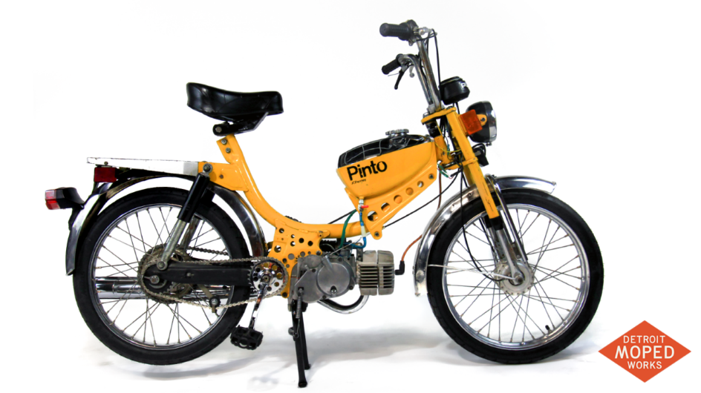 **Fig. 2.1.3** „JC Penney Pinto”

## 2.2 Purchasing List

Here is the main cost list for starting my build. Through this learning experience I had spent money on components I didn’t need and made mistakes. This is to be expected when building something for the first time. I was pressed on time and didn’t have the choice to order certain components late into the build process. Some of the costs are a one time purchase. For example the cost of my next battery pack will be much less since I have left over supplies and a spot welder already. There are also costs from metal fabrication, and small hardware which I didn’t take note of. There is about $200 in un needed purchases on this list, although I’m sure by the end of everything my build averages at $1500. This isn’t bad as an electric motorbike with similar performance can cost upwards of $10,000.

## 2.3 Frames

The frame we decide to make will play a vital part in our build. Most of the build is plug and play, although the biggest change is going to be coming from creating a new frame. This will vastly change the way our bike feels and looks. I will go over a few different types of frames, materials, and explain why I made the decisions I did.

### 2.3.1 Materials

The materials used in frame construction are essential. They will impact rigidity, weight, and cost.

Steel:

Most commonly, manufacturers use steel for budget-oriented motorcycles, like commuter bikes & mopeds. These are usually made from steel tubes which are bent and welded together.

Aluminum

The next most common metal used is aluminum. Aluminum is ⅓ the weight of steel, meaning that parts can be thicker and stronger while reducing weight. Depending on alloy, aluminum can be malleable, or as strong or stronger than steel. One of the downsides is that aluminum can be more difficult to weld than steel.

Carbon fiber:

As with cars, performance motorcycles have started opting for even lighter and stiffer materials such as carbon fiber, magnesium, and titanium. These are more costly than traditional materials, but offer unparalleled performance. These materials are used in MotoGP, however they have limited use in production bikes. For general use, aluminum or alloy chassis is more than satisfactory.

### 2.3.2 Frame Types

Backbone Frame

This is one of the most basic and economical types of motorcycle frames. As the name suggests, this frame resembles a spine. In this design, the amount of steel used is less than other types of frames, thus it keeps costs down. The engine is bolted onto the frame and generally hangs off the bottom. It is neither cradled nor does it contribute as a stressed member. My JC Penney Pinto utilizes a backbone frame construction. These frames lack in strength and torsional rigidity, however they are suitable for low power applications.

single cradle frame

This frame design is also simple and cost effective. There is one down tube in this design making it similar to a bicycle and certain backbone frames. These are usually made out of steel tubes bent and welded together. The factor that makes it a cradle frame depends on if the engine is a stressed member or not. In some cases the engine acts as a member of the chassis and bears stress. Compare this to the backbone frame where the motor hangs off the bottom rather than being cradled in the frame.



**Fig. 2.3.2** „TVS Radeon” (utilizes a single cradle frame)

Double Cradle Frame

Also called double down tube chassis frames. These are similar to single cradle frames, except instead of one pipe going down, these have two tubes going down to support the engine. This poses a significant benefit regarding strength and rigidity. Despite the extra material, the cost isn’t much higher than single cradle frames. These frames are built for higher power applications and can handle forces during high lean angle and heavy braking much better than a single cradle frame. This is a relatively old design and not the best suited for performance oriented bikes although they are still a popular style among enthusiasts.



**Fig. 2.3.3** „RE Continental GT650” (Utilizes a double cradle frame)

Perimeter Frame

This is the most commonly used frame among high-performance sports bikes. This frame is established on research from motorcycle racing. It suggests that the bike’s rigidity significantly improves if you connect it’s steering head to the swing arm in the shortest distance possible. Almost all modern perimeter frames are made from aluminum.

**Fig. 2.3.4** Example of a perimeter frame

Trellis Frame

The trellis frame is similar to a perimeter frame. It also focuses on connecting the steering head with the swing arm as directly as possible, however, the main difference is the way the beams are constructed. The trellis frame uses numerous short steel or aluminum beams welded together, forming a trellis like structure. In most cases, the trellis frame is stronger and lighter than perimeter frames. They are also simpler to manufacture since the frame is welded from pipes rather than machined. This is the preferred frame by many performance bike manufacturers.

**Fig. 2.3.5** „KTM 390 Duke” (Utilizes a trellis frame)

Monocoque frame

 Monocoque frames are frames constructed from one super stiff piece of material. They are typically used in cars and are usually metal, although in rare performance vehicles they can be made from carbon fiber. These are very rarely used for motorcycles and can be expensive to make unless you have a massive production scale. These are used for hyperbikes and motorcycles with extreme power that require unconditional torsional rigidity and lightweight construction.

**Fig. 2.3.6** monocoque motorcycle frame ( Kawasaki)

## 2.4 Construction Plan

Now that I have a list of components, it is vital to come up with a workflow needed to complete this project. This looks like :

Inventory -> Modeling <>building battery —> build frame -> assemble -> testing phase

Inventory is without a doubt the first step. By having all my parts accounted for, I can begin modeling each component in CAD in order to model the frame and create my final assembly model. The battery is tricky, because the configuration I build it in will effect it’s size and how it fits into the frame. Therefore I decided to model the battery in CAD before I built it in real life. This allowed me to continue modeling the frame even though the battery is not complete and also help me decide on the right configuration.

There were multiple prototype models until I found a general direction for the styling of the frame. As far as style, I really like the double cradle frames. They have a nice classic look and are a basis for cafe racer motorcycles. The wheels and suspension from my moped are also similar in size to these motorcycles whereas performance motorcycles have smaller and wider wheels with larger forks.

My plan from the beginning was to make my motorcycle using carbon fiber. I had a general idea of how I would build it and that helped me in modeling my frame. It is based on a double cradle frame as far as style and dimensions go, although the difference is that there will be no pipes. It will utilize big rectangular pieces of carbon fiber which are technically a single cradle except offer the width of a double cradle.

From here I must build the battery. This in simple terms requires connecting our batteries in series and parallel connections in order to achieve the required voltage and amperage.

The next step is building the frame. This will be done by referencing our CAD frames dimensions and building a mold from foam. We will then make the frame strong by wrapping our foam in carbon fiber and epoxy.

From here, mounting our components should be easy and we can begin testing our product. From here we can directly work to fix problems as they arise and gradually improve our design.

# 3. CAD Modeling Process

When creating a new prototype design, it’s very important to be able to visualize your work. CAD software is greatly beneficial when creating mechanical systems. Modeling a 3D replica of all of my physical components will allow me to create the frame and work out dimensions and quirks before building it in real life. This will help make the physical build process much quicker, as well take away any guess work of components not lining up correctly.

## 3.1 Prototype Model

The prototype modeling of my motorcycle actually began prior to having all my components sorted and modeled. It was more of a creative artistic endeavor rather than an accurate engineering model, although this playfulness is what sparked the rest of my build.

I needed to do rough modeling of my JC Penney Pinto components prior to starting my build. I did this because I wanted to see if it was possible to create an appealing frame using the pinto frame. I needed to know if it was even possible to use those frame components and have my EV components fit nicely in the final product. It is not necessary to do a rough model, as I could’ve started with accurate components, but it does save time and inspire hope moving onwards.

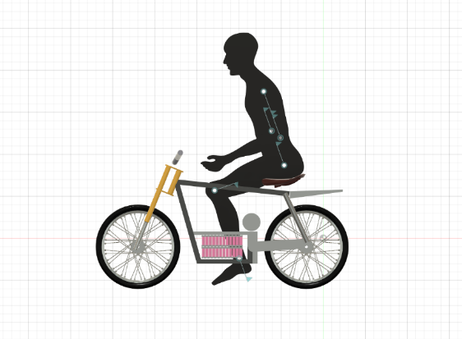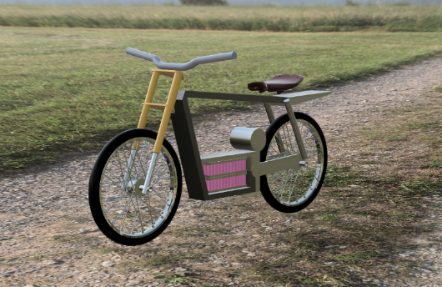I started by modeling placeholder components for my pinto. This includes 17” wheels, forks and rear shock, and using a free 2D asset of a human man scaled to be roughly 6’ tall. From here I was able to model the rough geometry of my frame to my liking. Below is the result.

**Fig. 3.1** My initial CAD prototyping/ rough dimensioning

## 3.2 Assisted 3D Modeling

There are several methods for modeling accurate components. I will explore some of the different methods including photogrammetry and 3d scanning before I enter the more painstaking process of measuring and modeling by hand.

For most of my components, scanning wasn’t actually needed. I decided to try out some of these different methods because I thought I could save time when modeling more complicated geometry such as my Pinto’s rear subframe.

### 3.2.1 Photogammetry

Photogammetry is a process that can recreate complicated 3D geometry using 2D reference photos. Because of how accessible cameras are nowadays, photogrammetry is a cheap and powerful option for 3D scanning.

It works by taking many photos at different heights and angles around your object. The more photos you take, the higher the detail and accuracy your model will be. Then the photos are imported into a piece of software on your computer. This software will analyze every photo to find common points of your object between photos and process these points into a 3D object.

I will be using my rear subframe for my photogrammetry test.

I took roughly 15-20 photos going 360 degrees around the subframe. I then repeated this at different angles using a low, middle, and high angle. This way I ensure I will have reference photos on top and below the object. These 60-70 photos are then processed on my computer. I used a program called meshroom which processes photogrammetry photos into a 3d model.

The results weren’t good. I went back and tried painting my subframe blue, in hopes it would more easily recognize points although this result wasn’t useable either. Some people are able to get incredible results using this method, although it takes lots of adjusting by using different lenses and lighting. I think because of the size of the subframe and focal length of my camera lens, I didn’t have ideal conditions for a good scan. The rounded contours of the subframe can also be hard to pick up. Having jagged edges and identifiable faces is much easier for the computer to process

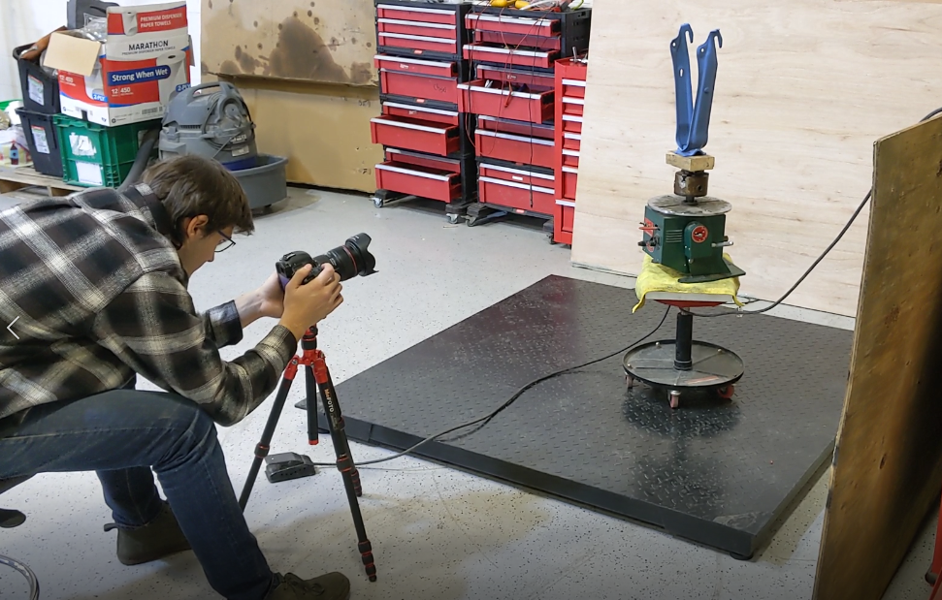

**Fig. 3.2.1** taking photos of the rear subframe to be used with photogammetry

I think if I kept playing with settings I could have found a way to produce an accurate scan, although I decided to stop my pursuit here. I also wanted to pursue other options such as 3D scanning..

### 3.2.2 3D Scanning

This is the more common method among professional engineering work. 3D scanners are a sort of camera which create a 3D point cloud of data by looking at the surface of an object. There are different methods and technologies for achieving this although some of the most common are laser based, projected or structured light scanners. They are easier to use than photogrammetry although it comes at a cost. Buying a 3d scanning camera can cost in the thousands, and hiring a business to do scanning work also can cost hundreds of dollars.

While that sounds pretty final for my budget build, fortunately there is a cheaper option. XBOX 360 actually shipped with a pretty powerful hardware called the XBOX Kinect. This came equipped with an infrared projector and a monochrome CMOS sensor which work together to see the room in 3D regardless of lighting conditions. For gaming this brought a new plethora of commands and features by allowing you to use your body movements as input. Anyways, years down the line somebody developed a way to take advantage of these inexpensive sensors and create 3d scans with them. A xbox 360 Kinect will run you about $30 and a USB adapter will cost $10. So for $40 you have a pretty decent 3D scanner. Not bad!

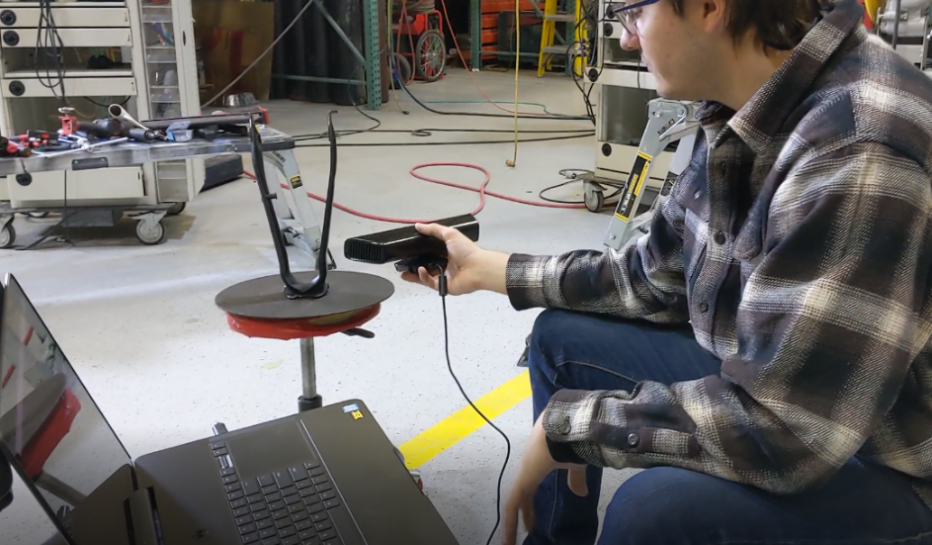The Kinect plugs directly into your PC and utilizes a program called Skanect. As you walk around an object, data is automatically scanned and you can literally see the model come to life as you wave the camera. This is much easier and more satisfying than photogrammetry. Once you have a full scan, you can export it to whichever popular 3D file type you want and then proceed to clean up the final mesh.

**Fig. 3.2.2** 3d scanning using the „Xbox Kinect”

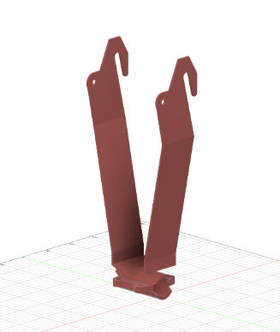The final 3D model actually didn’t turn out bad, although it still wasn’t good enough to use in my design. It was still helpful though because it allowed me to accurately create a model by hand while using the Kinect scan as a guide for angles and lengths. I was able to make a rear subframe model with accurate mounting points for my rear shocks, wheels, and mount to the frame.

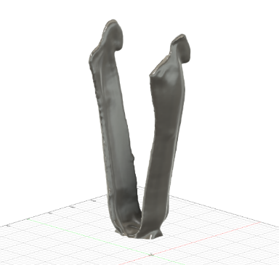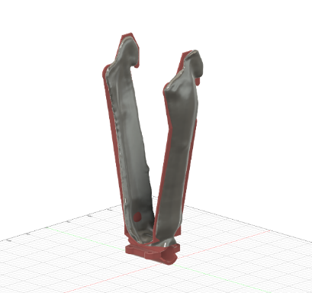

**Fig. 3.2.3** 3D scanned results overlayed with my CAD model (Rear subframe)

## 3.3 Modeling my components

Using calipers, tape measure and rulers I was able to model most of the components with fairly good accuracy. I also used pre-made assets when possible.

### 3.3.1 Controller

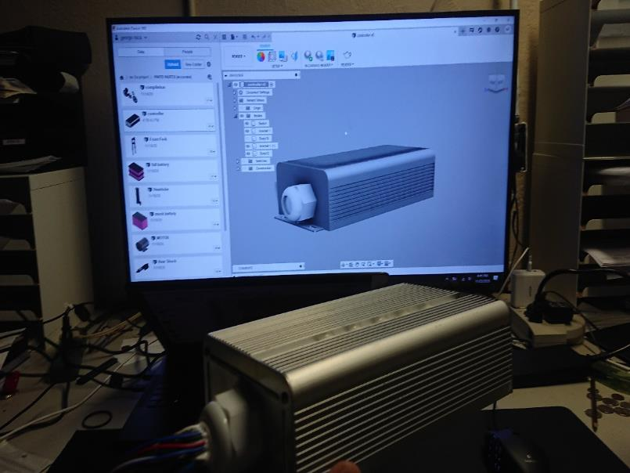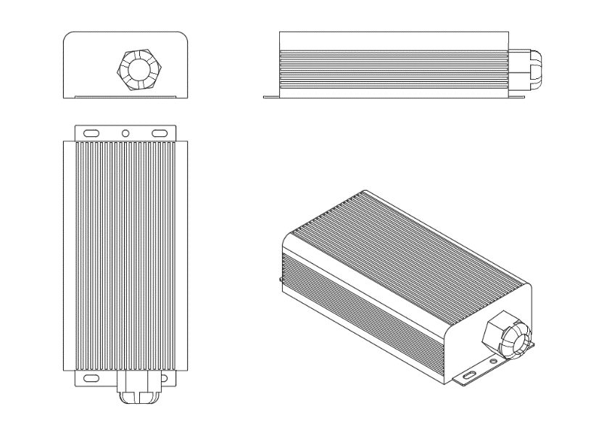

**Fig. 3.3.1** cad model of my controller

### C:\Users\georg\Desktop\fork.PNG3.3.2 Suspension (Front fork & Rear shock absorber)

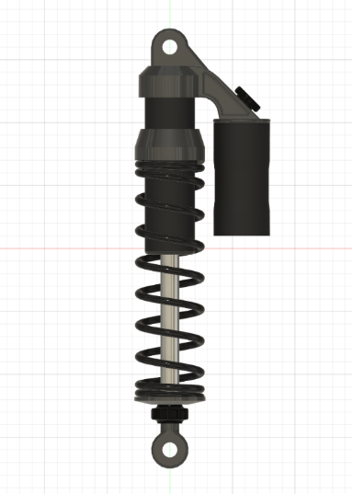

**Fig. 3.3.2** CAD models of the front fork and rear shock absorber

### 3.3.3 Wheels (front & rear with sprocket)

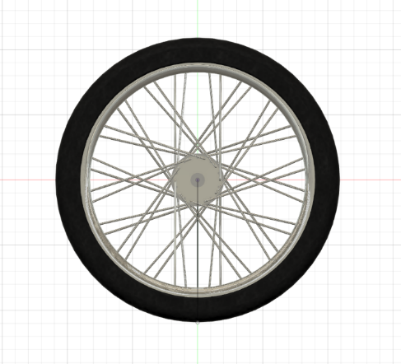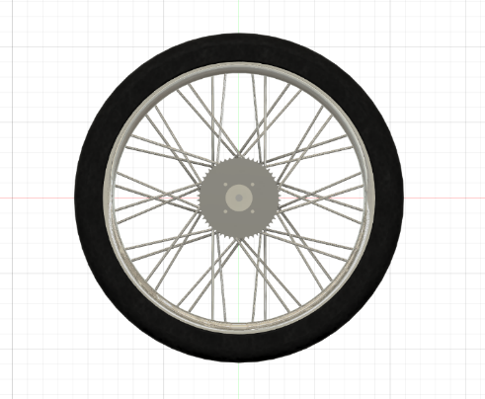

**Fig. 3.3.3** CAD models of front and rear wheels

### 3.3.4 Motor

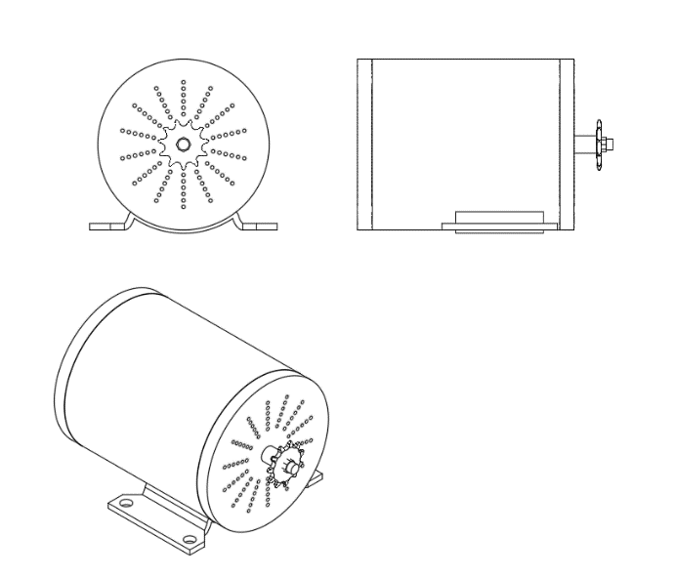

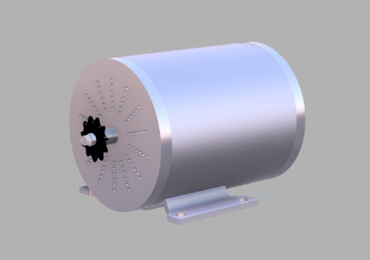

**Fig. 3.3.4** CAD model of my motor: BLDC (3000W/72V)

### 3.3.5 Battery

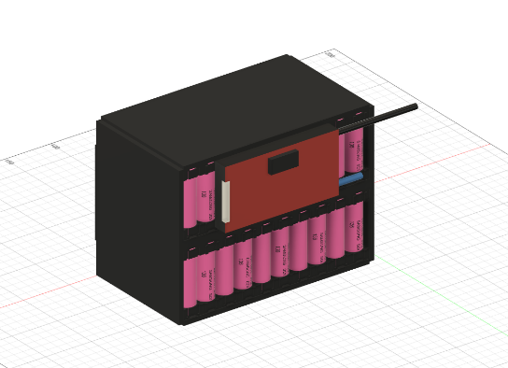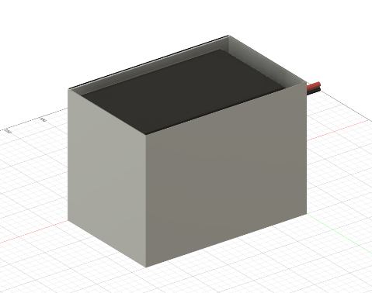This is the final model I decided on for the battery. This sketch served as my guide when it came time to build it in reality.

**Fig. 3.3.5** CAD model of the battery with & without protective casing

## 3.4 motorcycle Assembly

By using my individual components, I was able to place them in relationship to eachother and draft my frame in regards to this. I picked a wheelbase, fork angle, and worked from what locations were already determined. For example the fork, shocks, and trailing arm are directly tied to the wheels. The only adjustability is suspension angles. From here I just need to fill in the middle.

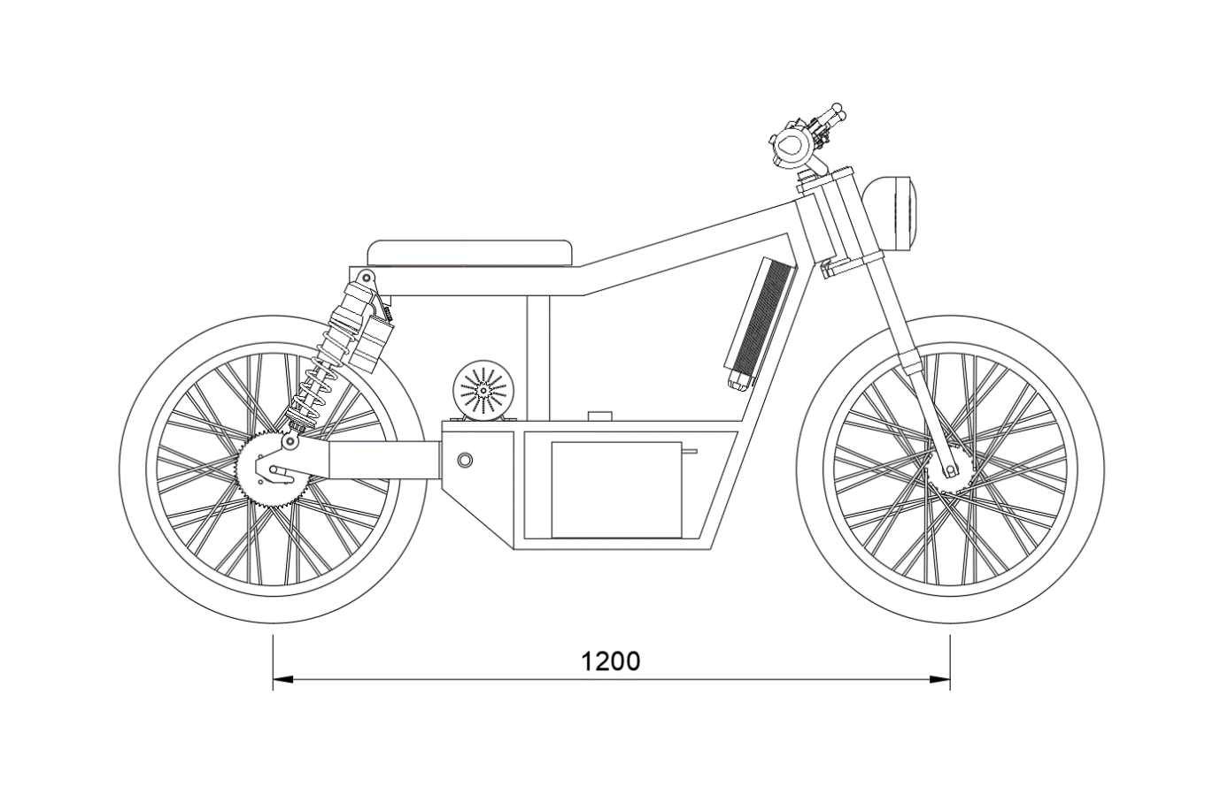I decided it would be good to put the battery at the lowest point, creating a low center of gravity. The motor, controller, and junction box will all sit on the bench above. It’s incredible how small electric motors are in comparison to gas engines. There is space to double or even triple the battery as well as adding a storage container.

**Fig. 3.4.1** CAD Assembly of my motorcycle with wheelbase measurement

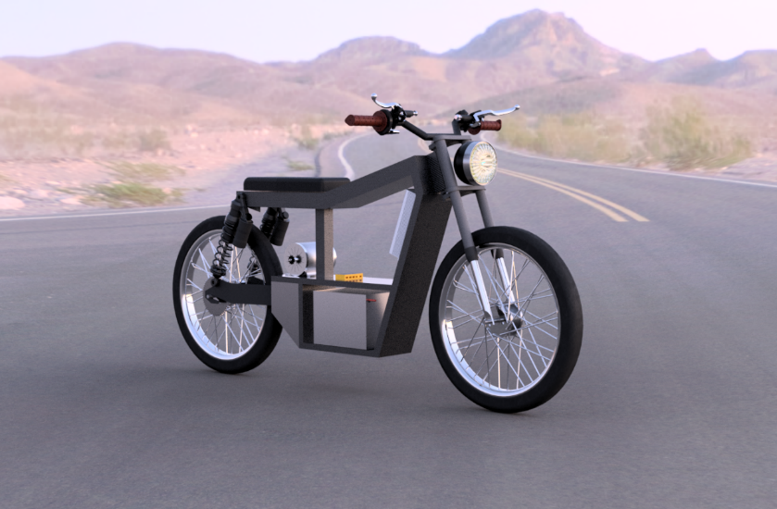

**Fig. 3.4.2** artistic render of the motorcycle assembly

I want to add that this design has one major flaw. I placed the motor above the trailing arm. To the inexperienced eye this doesn’t look like a big deal although I’ll explain why it’s important. The motor is connected to the rear wheel via a chain (not pictured). As the motor pulls the chain, the rear shock will compress and the distance between the motor and the rear wheel will get closer. This creates slack in the chain and causes the chain to skip. It is vital that this distance can’t change, which is why this design is flawed. Most motorcycles put the engine on the same axis with the trailing arm. By doing this, the trailing arm functions aș a solid bar ensuring that the distance from motor to wheel always stay the same. Unfortunately I didn’t realize my mistake until I had already built and started testing my motorcycle.

## 3.5 Frame

This is the naked frame. These measurements and angles served as my guide for building my physical carbon fiber frame.

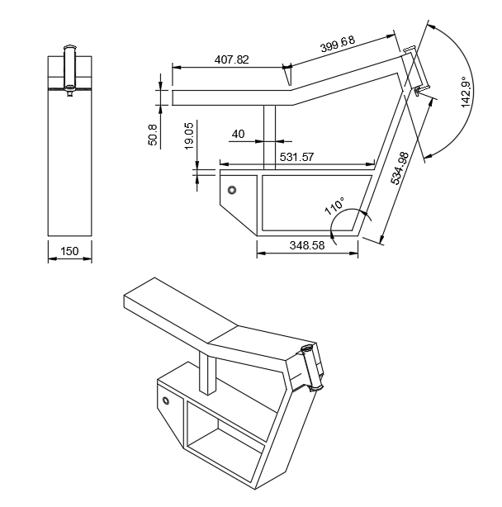

**Fig. 3.5** technical drawing of the frame with measurements

## 3.6 Stress Analysis of the Frame

Stress analysis is a engineering discipline that uses many methods to determine the stresses and strains in materials and structures subjected to forces. This is based on complex mathematics, although nowadays most of this is done through computer simulations.

I want to use stress analysis in order to see how my motor’s torque will effect my frame structure. This will show me weak areas which are subject to bend or break. I started by applying 50N of force to the trailing arm mounting point. The pulling action of the motor will translate into torque against this section of the frame. This is much more than my motor can output although it will help give us more dramatic results.

The figure below shows a stress analysis on the frame. Dark blue are areas under the least stress and lighter blue going into yellow shows areas which are under the most stress. The outline underneath shows how the frame has bent and moved forwards on the bottom.

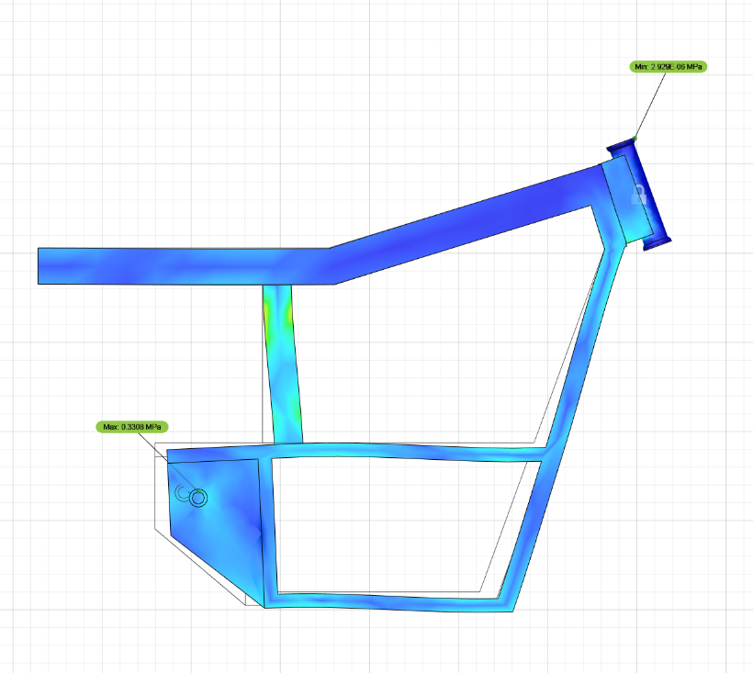

**Fig. 3.6.1** frame stress analysis result

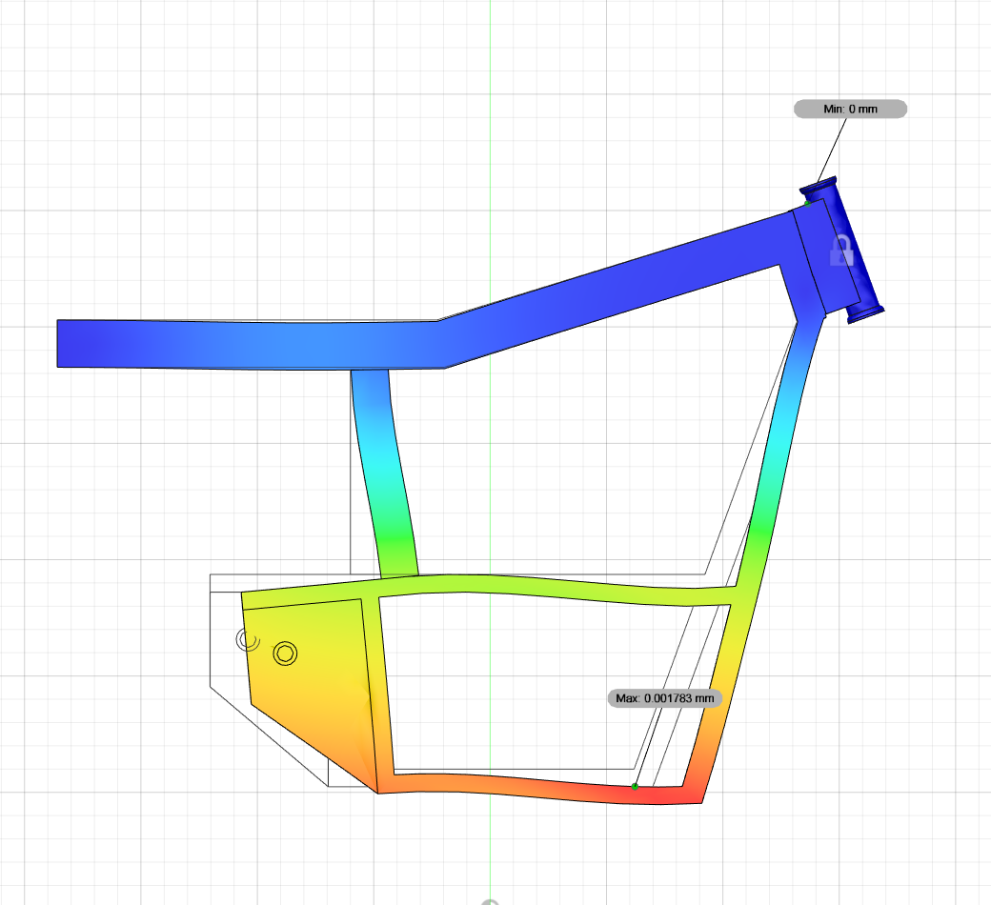Here is a displacement model. The colors represent how far areas have moved from their original point. In this way we can have a better idea of how our frame could bend. The hotter the color, the farther it has moved from it’s base point.

**Fig. 3.6.2** Result of the displacement analysis on the frame

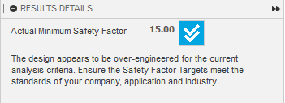 These results are all visualizations of the most dramatic cases. Our motorcycle will under no case be under this amount of stress. The analysis actually proved to be succesful. It shows that our design has a actual minimum safety factor of 15, and our frame is over engineered for it’s use case. „Target meets the standards of your company, application, and industry.”

**Fig. 3.6.3** Details of stress analysis results on the frame

# 4. Battery Build

## 4.1 Lithium-ion batteries

For this part I will explain how Lithium ion batteries work: technology, compare with acid batteries, etc. I will also use my experience building a Lithium-Ion battery, which I used for an electric motorcycle prototype. The same principles apply to how to build a battery for electric and hybrid cars

### 4.1.1 Characteristics of lithium ion batteries

A Lithium-Ion battery is a type of battery that can be charged and discharged when Lithium ions move from a negative electrode (anode) to a positive electrode (cathode). (In general, batteries that are repeatedly charged and discharged are called secondary batteries, and batteries that are replaced are called primary batteries.)

Because Lithium-Ion batteries have a large storage capacity, they are used in many applications, including electronic products such as smart phones and PCs, industrial robots, manufacturing equipment and automobiles.

Lithium-Ion batteries are divided according to size, shape, materials used for cathode and anode.

### 4.1.2 How energy is stored in lithium-ion batteries

The Lithium-Ion battery is composed of:

1) Electrodes: Anode and cathode

2) Separator between electrodes

3) Electrolyte that fills the vacant place

The anode and cathode are capable of storing lithium ions. Electrical energy is stored and discharged as ions move between electrodes through the electrolyte bath.

When you store energy (while charging)

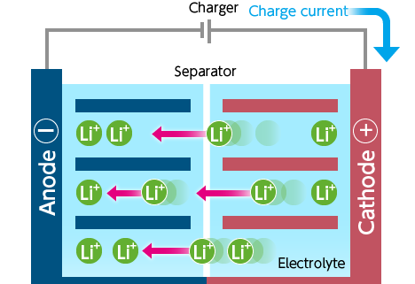

**Fig. 4.1.2** Diagram of the battery during charging

1. The current source transmits electric current to the battery.

2. Lithium ions move from the cathode to the anode through the electrolyte bath.

3. The battery is charged by the potential difference between the two electrodes.

When you use power (while discharging)

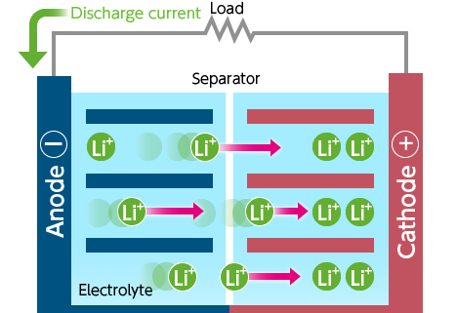

**Fig. 4.1.2** Diagram of the battery during discharge

1. An electric discharge circuit is formed between the anode and the cathode

2. The Lithium ions that have been stored move from the anode to the cathode

3. The electrical energy can then be used

### 4.1.3 How do lithium batteries compare with lead-acid batteries

In general, Lithium-ion batteries are lighter and can be charged much faster than lead-acid and sulfuric acid batteries. They are also good for the environment because they do not pollute nature with toxic substances.

The most important difference is in the way they are designed and built. Lead-acid and sulfuric acid batteries need three features that Lithium-ion batteries do not:

· Vertical orientation, to prevent loss of electrolyte flow

· Ventilation to remove gases formed during operation

· Routine electrolyte maintenance

Because of these differences, the low cost of sulfuric acid batteries must be weighed against their complexity and other secondary costs.

Although more expensive, Lithium batteries are the first choice for use in electric cars.

### 4.1.4 Criteria for choosing a lithium ion electric battery

The following characteristics are used to choose a Lithium battery:

· Voltage

· Energy density

· Upload rate

·Operating Temperature

· Duration of use

· Safety in operation

## 4.2 How to build a lithium ion battery

When I started this project, I had absolutely no knowledge about electric batteries and how electric vehicles work. I also had little knowledge of how best to connect the batteries, in series or parallel. I learned a lot and also made a lot of mistakes.

Before starting a project that uses electric batteries, it is very important to understand the components in the system and in what kind of applications they will be used. The first step was to buy a kit that contained a 3KW DC motor, 72V/ 45Amp/ 5800 RPM, controller, ignition key, chain, sprocket, throttle with forward/reverse position and 3 speed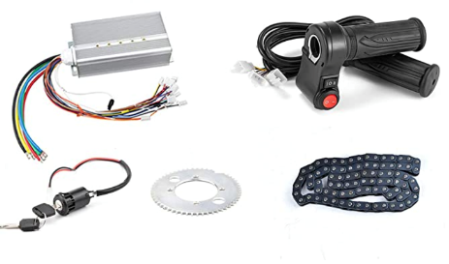 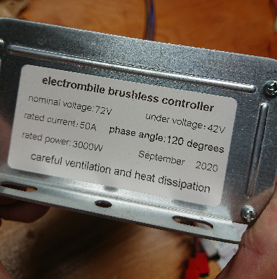positions.

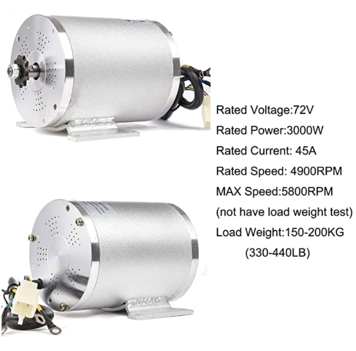

**Fig. 4.2.1** Pictures of my BLDC motor with technical details

When I received the kit I was very excited to try the motor using a 12V car battery. I was extremely disappointed when I realized that I would not be able to start the engine. To understand the cause, I started with the controller and the DC motor. The battery connects directly to these components, and it is extremely important to choose the correct voltage and amperage, otherwise the engine will not start. The controller requires a nominal 72V and a minimum voltage of 42V. I realized that I need a 72V 50Amp battery to start the engine. The rated electrical voltage (Voltage) is established for an electrical component or circuit for optimum performance. (eg 120/240V, 300V, 489Y/277V). The current electrical voltage at which a circuit operates can vary within a certain range that does not affect how the equipment operates.

Voltage is also a method of measuring battery current. For the battery I used, the maximum voltage is 84V, and the minimum is 50V. This means that at 84V the battery is 100% charged and at 50V it is 0%.

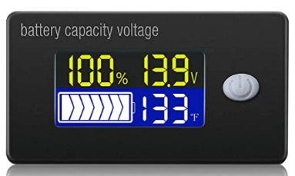 In this way, by measuring the voltage with a voltage device, you can find out in percentage how charged the battery is. This voltage device connects directly to the positive and negative terminal and can be programmed with the maximum and minimum voltage value. When the voltage is measured, this device converts the measurement to a percentage.

**Fig. 4.2.2** Voltage meter with screen

Voltage and amperage are two measurements for the voltage and intensity of electric current. Voltage is a measure of the voltage difference that makes the movement of electrons possible, and amperage is a measure of the volume of electrons. My controller is set for 50A. That means it won't draw more than 50A from the battery. Below is the technical chart for my engine. You can see the direct relationship between motor amperage and Power/RPM. It is logical that when we accelerate, the engine will use more current from the battery.

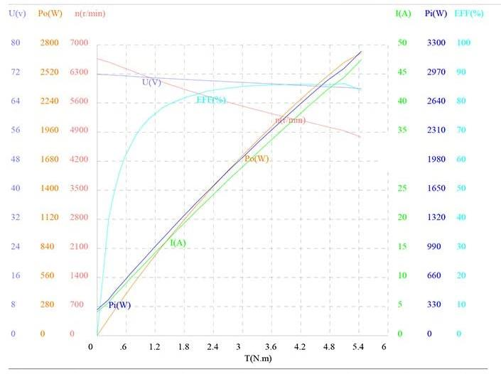**Fig. 4.2.3** Power graph from my BLDC motor

When the electric motor needs more power, it will automatically use more current to maintain the synchronous speed. The motor current increases in direct proportion to the load to which it is subjected up to the maximum limit (Full-load FLA, Nominal Load Amp)

With as much information as possible, we can determine what parameters matter when designing a project. First, electric motors should not be operated outside their rated parameters. Otherwise, they may overheat or deteriorate prematurely. The controller is a way to prevent the abnormal operation of the engine, and in addition, it can support the operation of the ignition key, cruise control, speed profile, anti-theft, etc. All electric vehicles need controllers.

Most Li-ion batteries are built using battery packs of less than 3.6V each. These batteries are connected in series and parallel to operate within the desired parameters.

Lithium-ion batteries are built in different shapes and sizes, but the most used is the 18650 model. It has a diameter of 18mm and a length of 65mm. It is very close to the size of a AA battery that is used in the market. It may be surprising that this type of battery is widely used in electric vehicles. The most popular battery used by Tesla, contains 7104 18650 batteries, capable of storing 85kWh of energy.

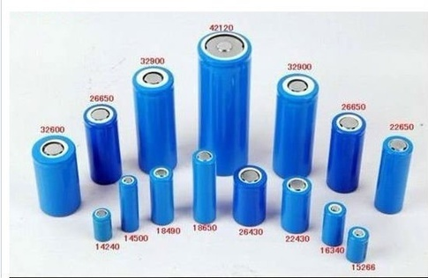**Fig. 4.2.4** Variety of lithium-ion battery sizes

**Fig. 4.2.5** Picture of a battery from a "Tesla" car

Tesla now uses a new style of battery, called the 21700, which is slightly larger (21mm X 70mm) and offers a higher density.

For my project I used the Samsung 30q 18650 battery.

|  |  |
| --- | --- |
| capacity: | 3000mAh |
| Discharge current: | 15A Maximum Continuous |
| Nominal voltage: | 3.6V |
| Maximum voltage: | 4.2V |
| Cutoff voltage: | 2.5V |
| Cell Protection: | Does not use protection. This battery has no protection and is intended for use ONLY in battery packs and never individually. To be used safely, it must have extra protections in the form of protection circuits or system management systems, which is not included. |

The next step in this project, is to see what would be the most optimal configuration using this battery. I need 72V and 45A, and each battery has 3.6V/15A. To make my battery work, I have to set up many series and parallel connections of the Samsung battery. Series connections are used to increase voltage, and parallel connections are used to increase capacitance and amperage.

### 4.2.1 Series connections

A series connection is when you connect the positive terminal of one battery to the negative terminal of the next battery, and so on. Each connection adds the voltage of the batteries in the circuit as a whole. As you can see from the following figure, 4 batteries of 3.6V each, when connected together have a total voltage of 14.4V. It is important to mention that the capacity of 3400mAh does not change, as does the maximum current that is eliminated.

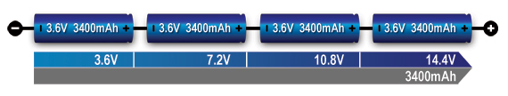**Fig. 4.2.6** Series battery connection diagram

For my project I need 72V. That's 20 Samsung 30q batteries in series.

3.6V x 20 = 72V

This battery will have 72V, 15A max discharge current and 3000mAh capacity.

### 4.2.2 Parallel connections

In the parallel configuration, the mA capacity and usage time increases, while the voltage remains unchanged. Parallel connections are made by connecting all the positive terminals of the batteries together, and the same for the negative terminals. Another important effect is that this connection increases the maximum discharge current.

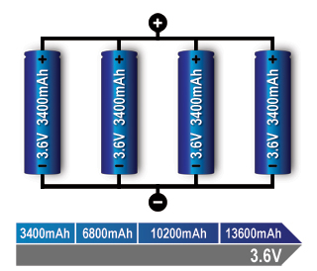**Fig. 4.2.7** Parallel battery connection diagram

Maximum continuous discharge current = The maximum current at which a battery can be discharged continuously. This limit is usually defined by the battery manufacturer, to eliminate the risk of excessive discharge, which could damage the battery and reduce its operating capacity.

The maximum discharge current for the Samsung battery is 15A. Connecting the batteries in parallel would increase the discharge current. Using this logic, I need 3 batteries in parallel to have 45A for the controller. Adding more than 3 batteries in parallel is acceptable because the controller will only use as much amperage as it needs. Many experts recommend to use batteries at half their maximum amperage. This means I can use 6 batteries in parallel, instead of 3. This way, we only draw 7.5A max from each battery, which helps to keep the batteries at the optimal temperature and increase their operating time.

Below is an example of batteries connected in series and parallel. There are 2 batteries in series that give 7.2V (3.6V x 2) and two batteries in parallel that give 6800mAh (3400mAh x 2)

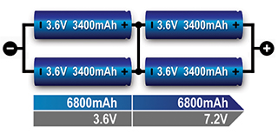**Fig. 4.2.8** Battery connection diagram in series and parallel

### 4.2.3 My battery configuration

Finally, for my project I decided to use the following configuration for Samsung 30q batteries: 20s6p (20 in series and 6 in parallel).

|  |  |
| --- | --- |
| Nominal capacity: | 18000mAh |
| Discharge current: | 90A Maximum Continuous |
| Nominal voltage: | 72V |
| Maximum voltage: | 84V |
| Cutoff voltage: | 50V |

Battery capacity and distance:

In the next step, since we now have the battery capacity, we can calculate how far the vehicle can travel. The first thing to consider is how much current is used by the motor.

My 3KW/h motor will use 3KW every hour when used at full speed.

Battery capacity is measured in mAh (milliamps), and to simplify the calculations, we will do the following conversion:

Watt/hour = Voltage x Capacity (Ah) WH = V x Ah

Our battery: 72V, 18000mAh = 18Ah

72V x 18Ah = 1296Wh

My 3000W motor will use 3000W in one hour at full power

1296wh/3000w = 0.432

0.432 x 60minute = 25.92 minute

In conclusion, my battery will be fully discharged in 25.92 minutes after being used at full power.

To calculate the maximum distance I can ride the motorcycle, I need to know the gear ratio and tire size. This way I can convert engine RPM to top speed.

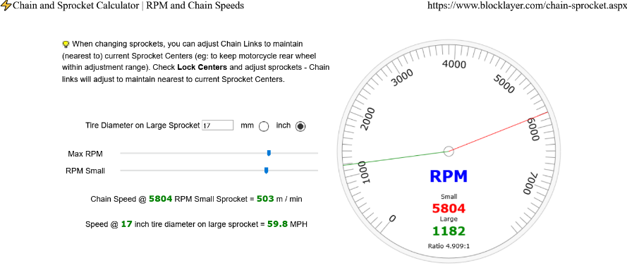**Fig. 4.2.9** Maximum speed calculator using wheel dimensions, gear ratio, and engine speed

Using the gear ratio, RPM and wheel size, my bike has a top speed of 60MPH or 100kMH. If we consider driving it at a top speed of 60mph, we can cover a distance of 26 miles or 41km.

In theory, these measures do not take into account the fact that we will drive at different speeds. It also depends on the roads it will be driven on and how it is driven. In cities, the speed is below 100km/h and the distance will be over 41km.

Fortunately for me, I'm not the first person to use this engine. This set with 20 series and 7 batteries in parallel (1656 WH) has already been used for a higher capacity, at a distance of 32km at a speed of 60-80km/h and 60km at a speed of 40km/h.

For my project I need several tests, where I use different values ​​for weight, wheel size, battery size, gear ratios.

I also read about electric bikes that "if you are careful about how you use energy, you will use about 20WH per mile. So with a 360WH battery you can travel about 18 miles.”

For my battery, this means:

1296WH/20WH = 64.8 mile/104 km

although, this calculation applies more to electric bikes with pedaling.

After getting past the theoretical part of the project, I will have to design and build it. I'll start by making a 3D model to visualize the final project.

I'm also going to use some cheap 18650 battery cases. This is a simple way to group the batteries together. We will make the battery bigger than it should be, but it is convenient for my project.

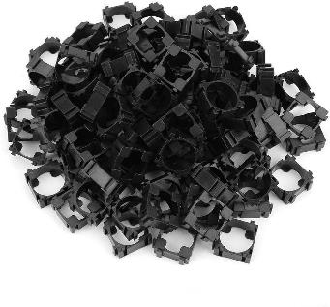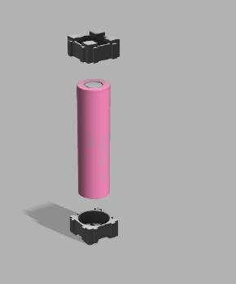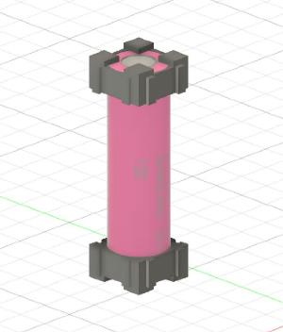**Fig. 4.2.10** Assembly with 18650 batteries and clamps

Using these clamps I can make the battery pack for my 20s 6p setup. We alternate the battery terminals between rows so that we can easily make series connections.

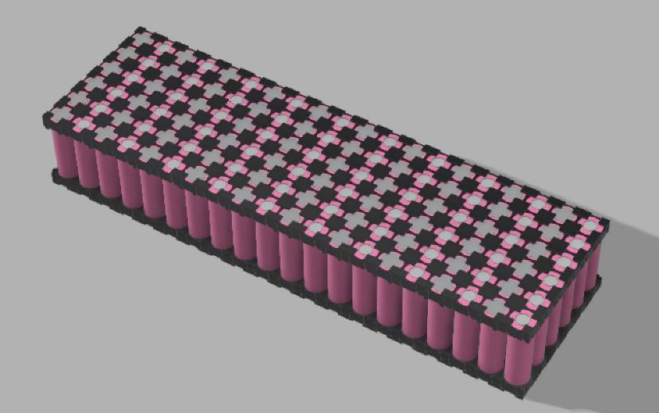**Fig. 4.2.11** Assembly with battery organization

For the connections I will use a strip of 0.15x8mm of pure Nickel. This strip will be welded using 6 points at each terminal. (6 points per connection, were recommended on the internet). Nickel strips come in rolls that can be cut to whatever size is needed.



**Fig. 4.2.12** Picture of the nickel strip

I started the construction with the connections in parallel. There are 40 connections in total (20 up and 20 down). Each parallel bank has 6 batteries, which will produce 3.6V, 90A current and 1800mAh. To produce 72V they must be 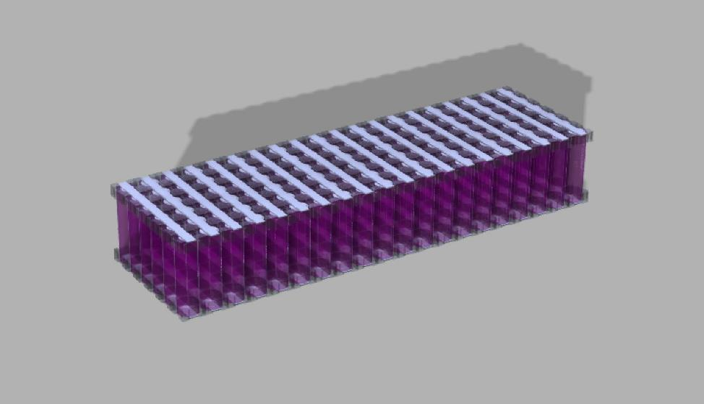connected in series.

**Fig. 4.2.13** parallel connections on my battery using nickel strip

In the figure below, you can see how the batteries are connected in series and parallel. The yellow line is a visual representation of the zig-zagging series connections, from top to bottom, connecting the terminals from – to +. In the figure, you can see that we are left with a negative and a positive connection. Connecting to these terminals, we will have a battery of 72V, 1800mAH with a current of use of 90A max.

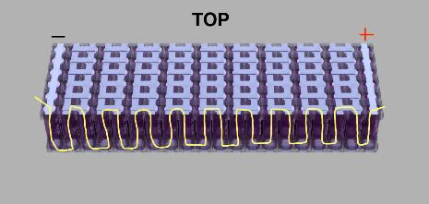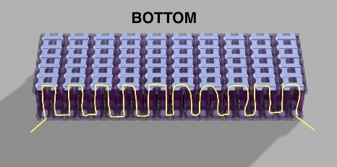**Fig. 4.2.14** Series and parallel connections and the direction path (yellow)

It is important to consider what kind of current is acceptable for nickel strips. For my project, 7-10A was the maximum and below 7A was optimal. That's why I made 6 connections between each series, instead of 1. The maximum current was 45A/6 connections, which is optimal for the nickel strip at 7.5A maximum. This way, the battery will not heat up when used at full capacity.

### 4.2.4 Battery management system (BMS)

In the specifications of the Samsung 30q battery it is indicated that "the battery is not protected and cannot be used individually or alone, but must be protected. In order to function safely, it must have a PCB (protection circuit board) or BMS (battery management system)”

The battery management system (BMS) is an electronic system that monitors the normal operation of the battery, for example protects the operation outside the normal limits, calculates secondary data, reports data, controls the environment, authenticates and balances it.

For my project I bought a BMS; 20S 72V 60A. It connects to the positive terminal in each series. It will monitor the voltage at each consecutive parallel group and maintain a constant voltage when charging and discharging. The BMS will stop charging when it reaches 4.25V and discharging when the voltage reaches 2.7V. If something is wrong with the battery, and it is not properly balanced, this eliminates an overcharge/discharge of the battery and the possibility of it being destroyed or shortening the operating time.

**Fig. 4.2.15** Documentation from my BMS explaining how to make the battery connections

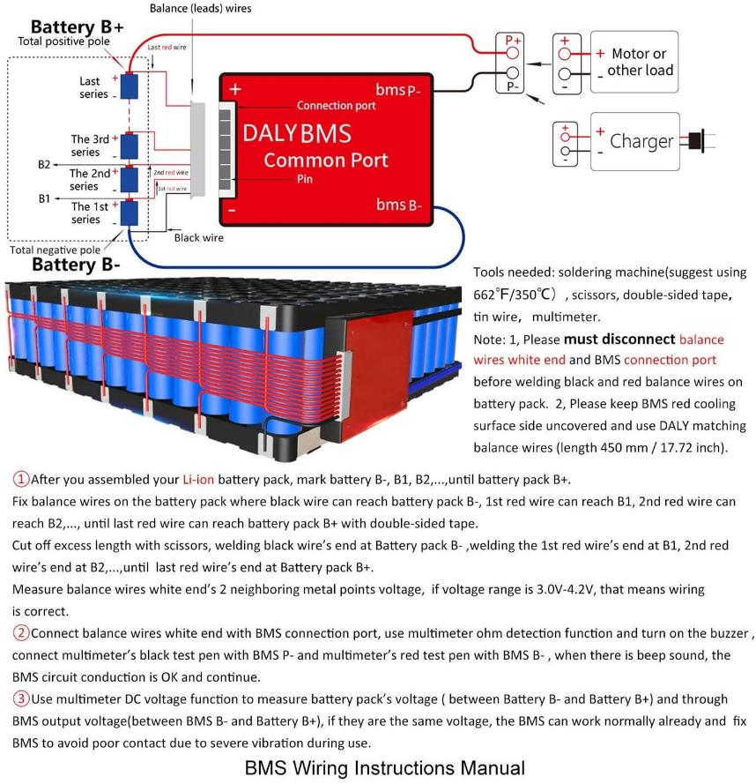

## 4.3 Construction process

I started the build process just like in the 3D model. The first time I welded the parallel connections, then the series ones. I didn't connect the plastic clips in the middle of the series because I will bend and stack the batteries on top of each other to use the space more efficiently than if I had a long battery.

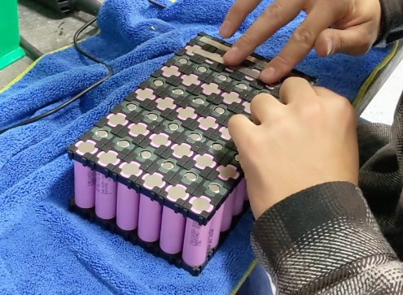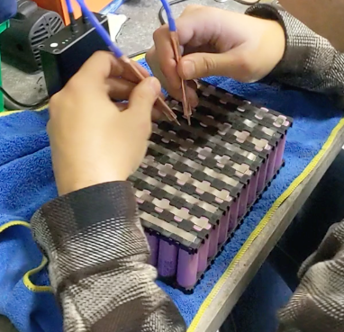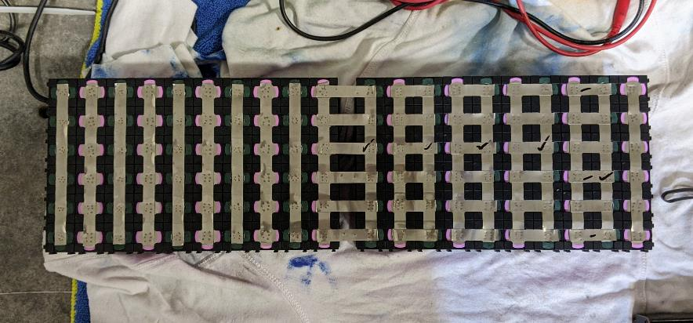

**Fig. 4.3.1** Pictures while spot welding the series and parallel connections to my battery

The main connections have been made. As can be seen from the adjacent figure, I extended the nickel strips and bent them at the corners. I added more material so I have room to weld the connections from the BMS.

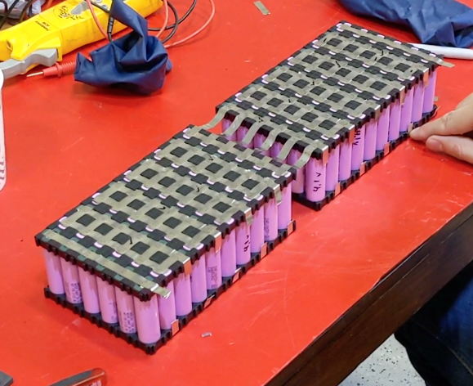**Fig. 4.3.2** The picture with the main connections made on the battery

It is advisable to add a protective heat resistant tape. This helps with battery temperature, and adds insulation. It is also recommended to use protective gloves, to insulate from electric shock of the person or the battery. Also cover the parts of the battery that you are not currently working on to help prevent shorting. Accidents can happen!

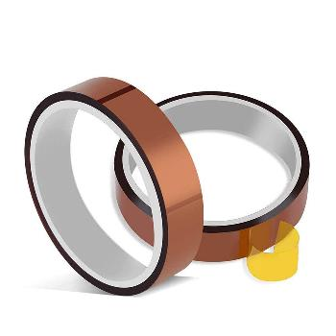

**Fig. 4.3.3** heat resistant tape

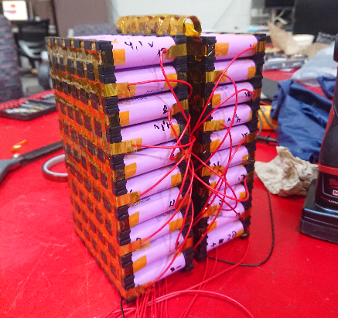I have to be very careful when folding the battery, because the positive and negative terminals are very close to each other. There is a risk of short-circuiting the battery. For this I added extra insulation to the terminal.

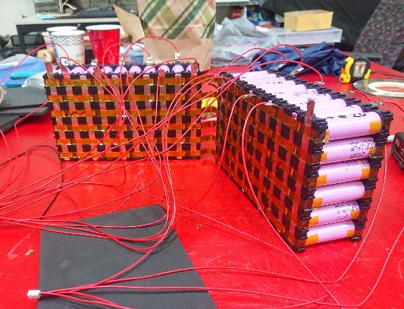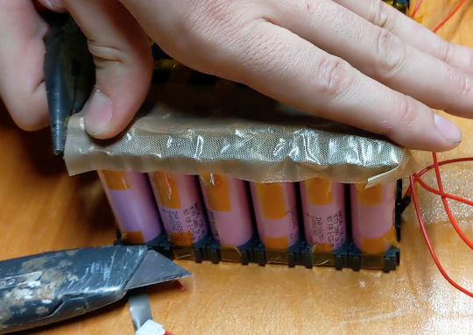**Fig. 4.3.4** The battery bent with the protective tape and the connections to the BMS

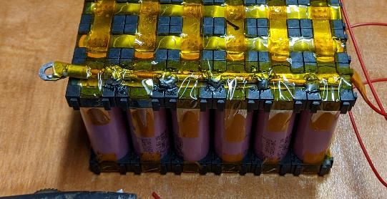

**Fig. 4.3.5** Extra insulation at the terminal

Instead of connecting the battery directly to the motor, I added an XT90 anti spark connector. This makes it possible to disconnect the battery from the engine and charge the battery separately.



**Fig. 4.3.6** XT90 anti-spark connector

I decided to add support foam and weld a battery case. The case will protect the battery from the elements and from unforeseen impacts.

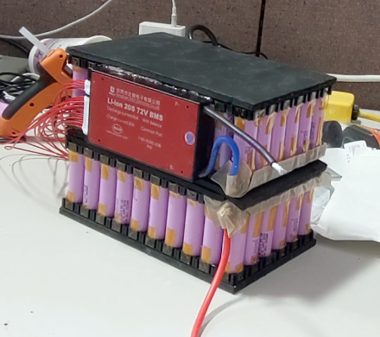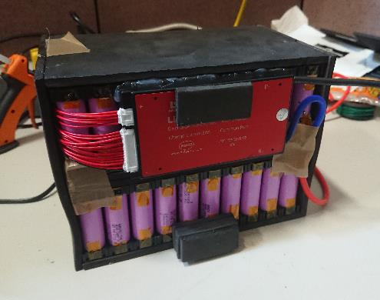**Fig. 4.3.6** The battery with the mounted BMS and the support foam.

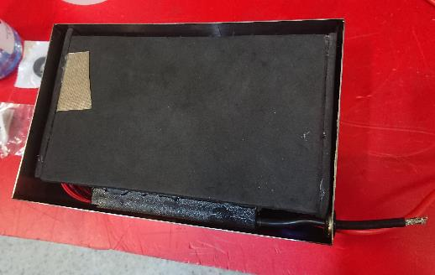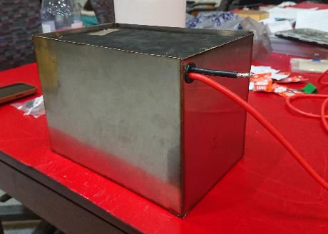**Fig. 4.3.7** Battery housing made of steel

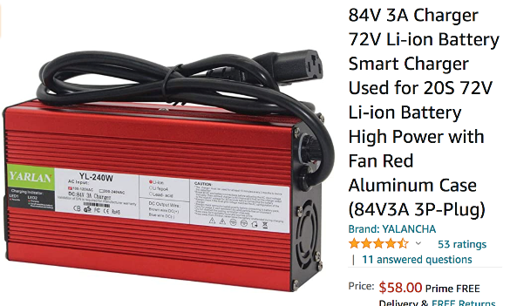

**Fig. 4.3.8** my battery charger

Before finalizing the battery, I tested all the components together. Everything went very well and the battery works exactly as it should. The charger works perfectly and stops when the BMS sees that the batteries are charged.

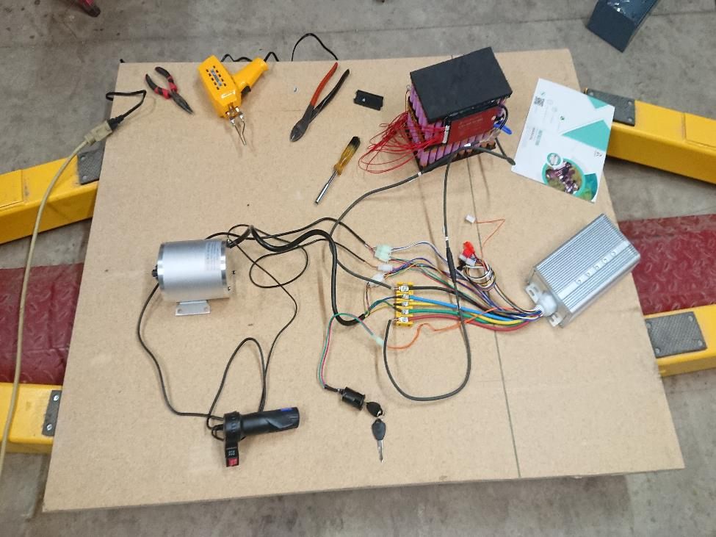**Fig. 4.3.9** Testing my components

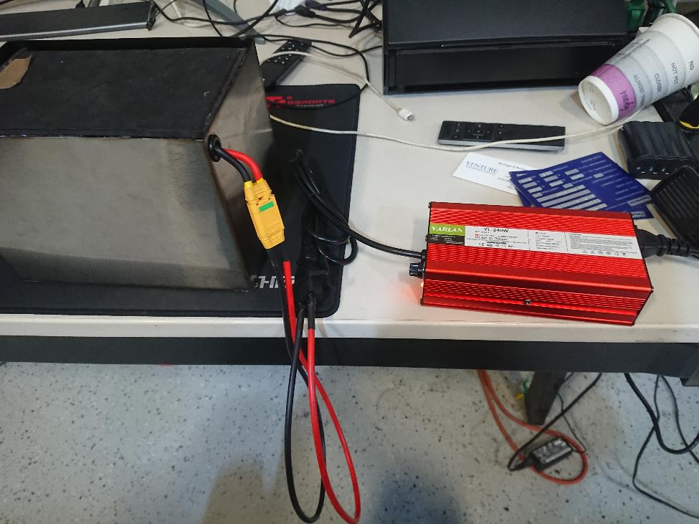**Fig. 4.3.10** Battery charge testing

# 5. Frame Build

The main majority of our frame will be built using carbon fiber. Carbon fiber is very strong and lightweight, meaning it should be able to handle the forces of our motor. Mounting points like the headtube, rear shock mounts, and trailing arm mount will be reinforced with metal, and we will use components from our donor bike wherever possible. The metal will be completely wrapped under the carbon fiber, creating a larger surface area to distribute the pressures acting on those points.

## 5.1 Carbon Fiber

Carbon fibers are literally just that. Fibers made out of mostly carbon atoms. Some traits include high stiffness, high tensile strength, low weight to strength ratio, high chemical resistance, temperature tolerance and low thermal expansion. To produce carbon fibers, carbon atoms are bonded together in crystals that are aligned parallel to the long axis of the fiber. This alignment gives carbon fiber it’s high strength to volume ratio. From these threads, they can then be bundled to form a tow, and then used standalone or woven into a fabric.

In most automotive cases, carbon fiber is referring to use of sheets of woven carbon fiber. By weaving the fibers into sheets, you can greatly increase the strength. It’s true that carbon fiber is light and strong, although this strength is only present when the loading is tensile along the axis of the fibers. This means that the sheet must be oriented properly in regards to the stresses.

While capable of high strength, carbon fiber weaves by themselves are like any material fabric. They come in rolls which can be easily folded and cut, but inherently will not hold shape or offer the properties we seek. Carbon fibers are usually combined with other materials to form a composite. By soaking a sheet of carbon fiber in epoxy and drying, the result will be an extremely strong and light sheet of material. This can be done with multiple layers of fabric with multiple orientations of weave. The more layers, the stronger the resulting product will be. This process is very similar to other composites such as fiber glass.

There are multiple methods for creating strong carbon fiber products, although almost all of them take advantage of the use of resins like epoxy.

### 5.1.1 Epoxy

Epoxy comes in liquid form in 2 seperate containers. There is epoxy resin, and a hardening agent. By mixing resin with a hardener, they undergo a chemical reaction which over the course of minutes or days will cure into an extremely hard adhesive. Epoxy can have many different resulting traits. The strength, curing temperature, and curing time is specific to each epoxy and thus it’s recomended to seek out a system that is good for your application. Once epoxy is cured, it cannot be uncured. So for carbon fiber this means that our malleable fabric once infused with epoxy and cured will become a strong material which holds shape. Any forces beyond it’s limit will cause it to crack and break

## 5.2 Carbon Fiber Process

### 5.2.1 Molding

One popular method for creating carbon fiber parts is through the use of molds. This is done by creating a negative mold for your product, and then carefully laying carbon fiber fabric fabric inside the mold in the shape of your final product. This can be done in multiple layers and weave alignments. The mold is then filled with epoxy and is heat or air cured. The resulting part is very corrosion resistant, stiff, lightweight, and strong. Parts in less critical areas are made using cloth already preimpregnated with epoxy and then layed into the mold. High performance parts using single molds are often vacuum bagged and or autoclave cured, because even small air bubbles in the material can reduce strength.

### 5.2.2 Vacuum Bagging

This method also can take advantage of the use of a mold and is often added to the process in order to improve the quality of the finished product. A bag is placed around the mold with a hose for pulling vacuum. For body panels like hoods, the mold can be placed inside of a big bag and by pulling vacuum during curing, it will ensure the carbon fiber sits as tight and close to the mold as possible. For more complicated products and molds this method can still be used but may require more bags.

There are a few methods for applying epoxy in this process. The first is called wet layup, where epoxy resin is mixed and applied to our fabric before being laid in the mold and placed in the bag. The other is done by infusion, where dry fabric is placed in the mold and bag while vacuum pulls resin through a small tube into the bag. The vacuum will evenly distribute the resin through our fabric and mold.

### 5.2.3 Compression Molding

A quicker method uses a compression mold. This is a 2 piece (male and female) mold usually made of aluminum or steel that is pressed together with the fabric and resin inside. Depending on the heat and resin, parts can be created very quickly. This method is used in big manufacturing settings where many parts must be created. It isn’t worth it for limited production because of how expensive it is to create a mold.

## 5.3 Building the Frame

I decided on a more DIY and unprofessional way for making my carbon fiber bike frame. It seemed to be the easiest and quickest way to start working and begin learning. I used a method called wet laying. This is done by laying your carbon fiber onto your mold and applying epoxy with a brush. Usually epoxy is added between layers to ensure it properly soaks through. The main difference is that it isn’t vacuumed while curing. Because of this there can be inconsistencies and air bubbles. The resulting material will still be strong although the appearance may not be as nice as a vacuumed mold, especially if the process is rushed. The other difference in my build process was how I created and used my mold. Creating a typical mold costs money and time. Neither of which I had. So what I did is use a combination of EPS and XPS insulation foam to create my frame. The simplicity of my frame design allowed me to easily cut and glue the foam pieces and recreate the frame structure. After I had this foam frame, I began wet laying carbon fiber around every part of the foam. Completely enclosing it in multiple layers of carbon fiber and epoxy. Once cured, the result would be a strong and light frame made out of foam with a strong carbon fiber shell. The foam remains inside, although because of how lightweight it is, the added weight is negligible. Acetone can also be used to disolve the foam from inside but for now I didn’t deem it necessary.

This is how I started building my frame. I measured peices of foam according to my frame design. I used a ruler and razer blade to cut them. I hot glued the peices together to start forming the whole frame. The white foam is 1 in EPS foam insulation board. The green foam is 2 in XPS insulation foam. EPS is slightly lighter than XPS. And XPS is closed cell, making it more dense and easier to cut cleanly and work with. The only reason I used 2 different foams is because the EPS was conveniently close to my bottom thickness and XPS was conveniently my thickness for the top.

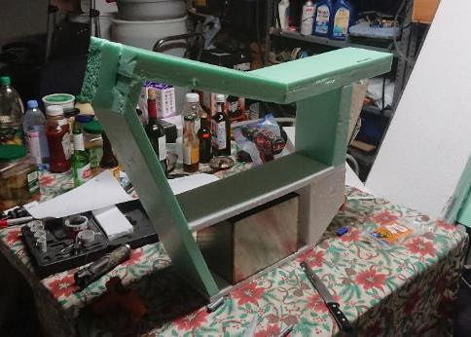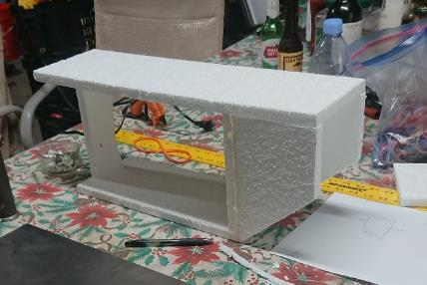

**Fig. 5.3.1** The beginning of the construction of the EPS and XPS foam frame

I cut out some reinforcement plates for my rear subframe mount. Since there will be a pipe going horizontally through the back side of the frame, It’s important to have a more solid edge than carbon fiber to rest on. Carbon fiber is very strong, but that strength is much less when applied to a thin edge like this. The edges can be brittle and crack like glass. These plates are glued into place and will be wrapped competely under the carbon fiber later on. This will distribute the forces caused by the rear subframe mount.

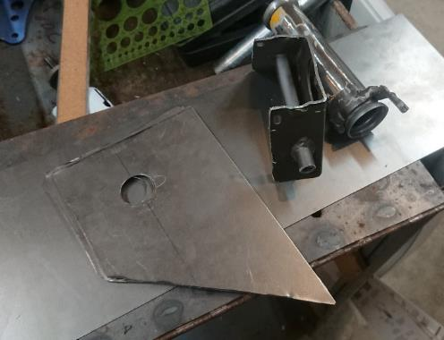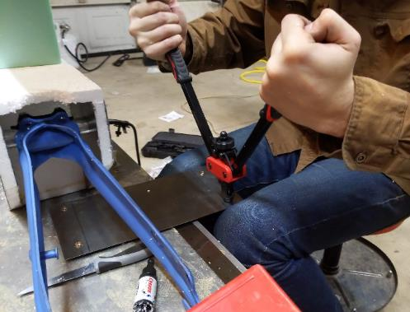 Here you can also see me adding rivet nuts to a sheet of steel. This sheet is meant to sit on the bottom shelf under the battery, and the battery case will screw into these rivet nuts, holding it into place. This plate will also be wrapped into the carbon fiber, making it a unified and strong part of the frame.

**Fig. 5.3.2** steel frame reinforcement

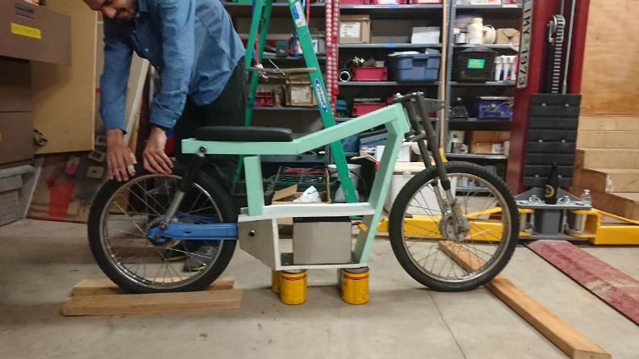 I did a quick test fit to ensure the frame components line up on my frame and everything lines up according to the design. I was happy to catch my first glimpse of the final product.

**Fig. 5.3.3** Checking the fit of the parts in the frame

I decided to wrap the frame in 2 parts rather than do it all in one go. The reason I did this is because I knew that after the frame was fully together, I wouldnt have space to fit my rivet nut tool in the middle shelf, and also would have a much harder time figuring out how to line up my motor sprocket with the rear wheel sprocket. Therefore, I decided to build half the frame, add my components, test them, and once everything is working properly, finish the frame. I also decided to cut the headtube from my Pinto frame and wrap that into the foam. This ensures that the fork will fit well and adds a level of strength and security.

The process for adding carbon fiber is as follows. I cut out pieces of carbon fiber fabric long enough to cover my sections. These are then brushed on to the foam with epoxy. I leave them overnight to dry and come back to find a hard piece of frame. One thing I learned that made my life much easier was using hot glue to hold the dry carbon fiber in place. Otherwise it would keep unpeeling and made my life much harder when trying t o brush on epoxy.

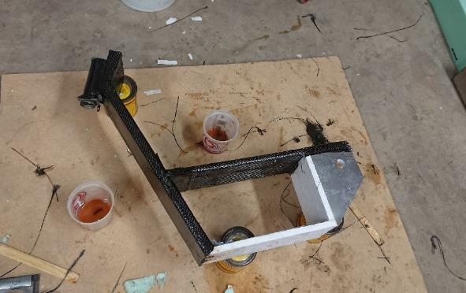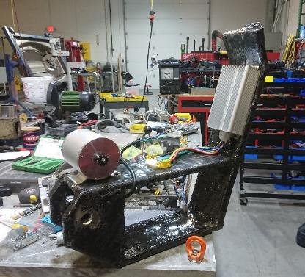**Fig. 5.3.4** Bottom frame wrapped with carbon fiber

There is a problem I was anticipating, and knew I would have to find a solution during fabrication. The placement of my motor in relationship to my rear sprocket actually causes the chain to rub on the trailing arm. From here I was able to make measurements to cut, modify, and reweld the trailing arm. I added an “L” shaped piece of metal in order to push that section away from the wheel and create an opening for the chain to pass.

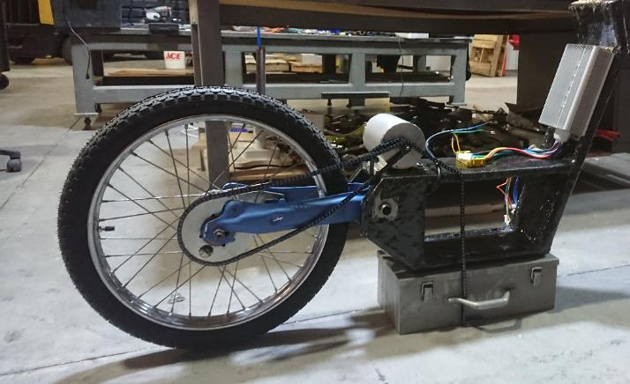

**Fig. 5.3.5** Problem with rear chain rubbing on rear trailing arm

Through careful measuring and planning, we were able to modify the trailing arm 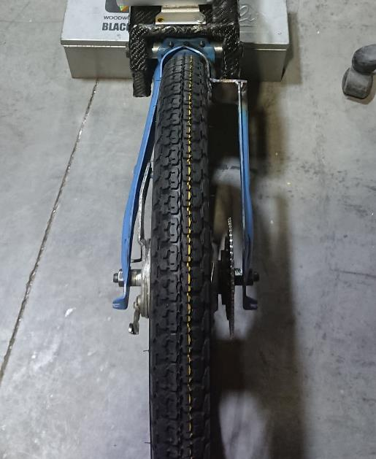while keeping the wheel aligned and straight.

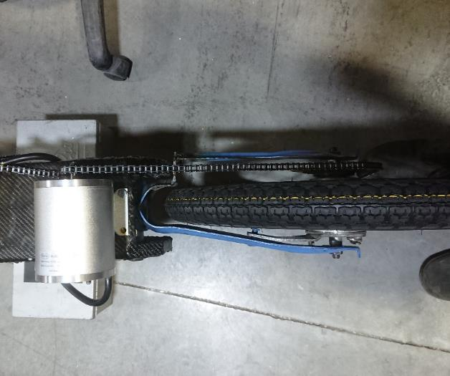

**Fig. 5.3.6** modified rear trailing arm

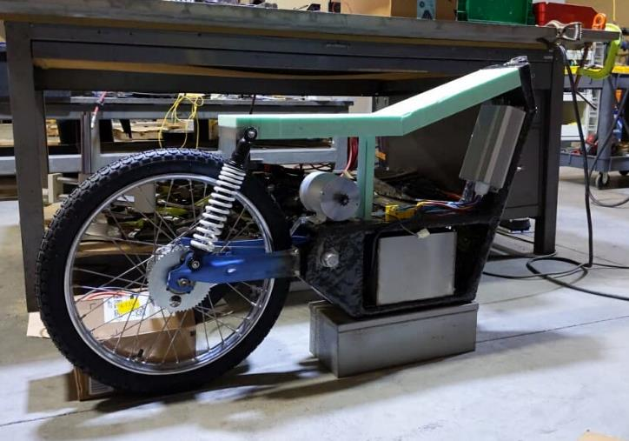 Now that we have the components all lined up and ready to go, we must add the top half of our frame so we have somewhere to sit, and also mount the top of our rear shocks. For the rear shock mount, I used a small block of aluminum with a hole for the through bolt that our shocks mount to. This aluminum block will get fully wrapped in with the foam and become a solid mounting point.

**Fig. 5.3.7** modeling the upper part of the frame with XPS Foam

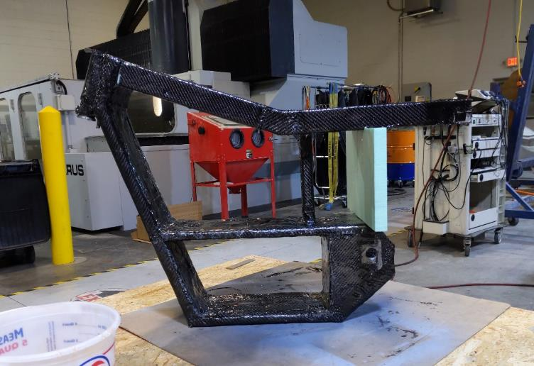 The rest of the frame is wrapped in the same way is the bottom. I have made sure to add extra peices of carbon fiber to cover any weak corners or seams between layers. In total the frame probably has 3-4 layers of carbon fiber. The bumpy appearance is due to the epoxy dripping while drying. This doesn’t effect performance and can be sanded down later to create a nice smooth finish.

**Fig. 5.3.8** Complete frame wrapped în carbon fiber

I mounted all the components and got ready to ride. The frame withstood my weight as I sat down. I pulled it out of the garage to give it it’s first test. As soon as I pulled on the throttle to accelerate harder, I heard a loud crack from the back. The motor had torn out from it’s rivet nuts and pulled apart the carbon fiber in the area. While I reinforced parts for the trailing arm, rear shocks, and even the battery, I didn’t reinforce the motor mounts. This was a complete oversight and a classic mistake due to rushing.

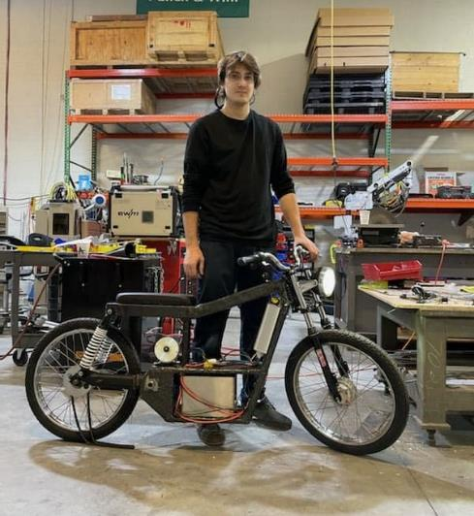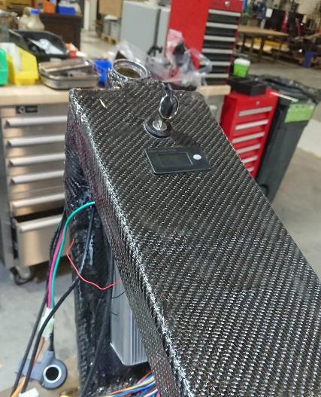

**Fig. 5.3.9** Top view with key and voltage battery screen & full side view

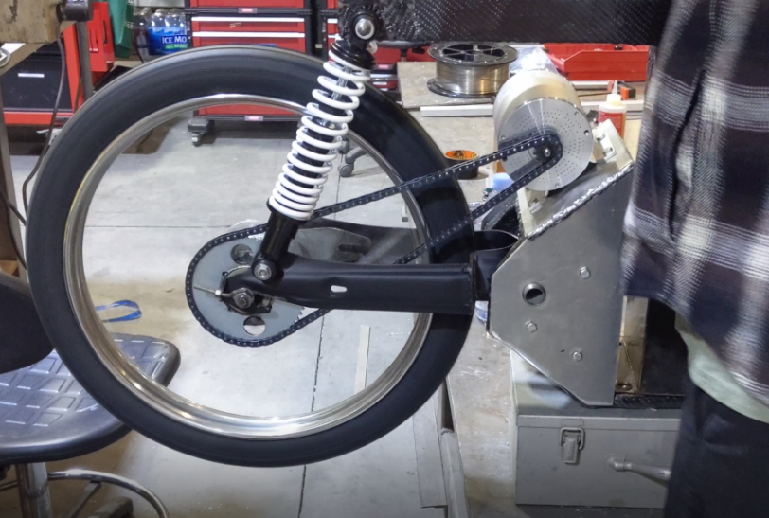 From here I decided to make a bracket that would take advantage of the rear subframe metal reinforcement. This bracket allowed me to start pushing the bike more and troubleshoot farther.

**Fig. 5.3.10** Motor testing with reinforced frame

# 6. Testing

## 6.1 Reinforcing the Frame

The bike does now ride, although there a few problems that need to be addressed. The torque of the motor is causing the rear shock to compress which creates slack in the chain and causes the chain to skip. The bike will get up to speed if accelerated slowly.

The next big problem is that the frame is actually weak relative to the forces acted on it. This isn’t due to the nature of carbon fiber itself, but more so to poor building. It is not uncommon to have 10+ layers of carbon fiber, while I don’t have even half of that. The reason I had so few was plainly due to inexperience. Carbon fiber is quite tricky to learn to work with. There’s many methods for reinforcing the material and positioning fabric to better handle forces. Without properly applying all these methods, you can have undesired results. This is all a learning experience, and I truly believe that if I had added more layers, this frame would function fine.

Anyways, this weak and flexible carbon fiber caused a few issues. My motor is firmly connected to this new bracket, although those forces are now just being transferred forward to the rest of the frame. As the motor pulls down, that whole section of the frame wants to come down also and as a result, the middle shelf is actually trying to separate from the supporting pillar. It actually did just that. It pulled the carbon fiber that was holding the bottom of the pillar. This is also something which could have been solved by properly using carbon fiber and adding layers. The bottom of the pillar was patched at the bottom with a few pieces of material, but it would’ve been much stronger if I had used a big piece of material to wrap around the bottom of the shelf.

By looking at my stress analysis again, you can see how the torque of the motor can cause the bottom of the frame to bend forward. All of these issues contribute to the chain skipping and not being able to put the desired power down. Unfortunately I didn’t have my stress analysis made at the time.

So now that I have a list of problems, I must start looking for solutions. The first possible solution is to start adding layers of carbon fiber. The thing is that at this moment I didn’t have time. Adding carbon fiber at this point in the build would have taken too long between epoxy and drying. Whereas I only had 5 days to finish, before leaving to Romania till the end of the school year. Instead of using carbon fiber, I decided to start reinforcing with aluminum. Every time something would break or bend, I would add more aluminum. It is a messy way to troubleshoot, although it did work.

The first reinforcement was to add a long plate that stretches down the front of the frame, down and under the battery pack, where it attaches to the motor bracket. There is a long piece of aluminum welded to the front plate which also extends more directly to the motor bracket. This reinforcement should hold the motor from pulling back and also reinforce the whole bottom of the frame against twisting forward. Since the center support pillar was also flawed, I added a bracket that comes around the top of the frame and holds it to the bottom reinforcements.

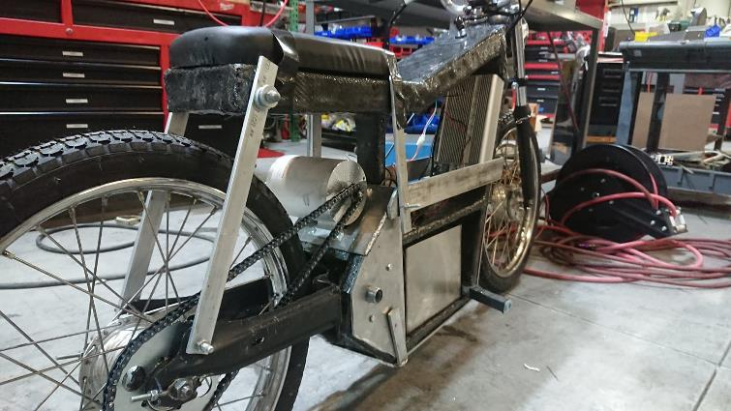

**Fig. 6.1** reinforcement with steel bar instead of rear shock

At this point, the motorcycle actually became rideable. The chain still skips although much less. The skipping was farther negated by swapping the rear shocks for a metal beam. This basically turns the frame into a hard tail and ensures that the shocks won’t be able to compress and promote chain skipping.

I was finishing this build around February. Michigan was being faced with heavy snow, ice and harsh wind at the time. Not an ideal setting for testing a motorcycle. Although I worked hard to get to this point and so I pushed it as much as I dared. I was able to reach 60 Km/h with no issues and with plenty of power to spare. I decided not to push it past this point for fear of slipping on a patch of ice.

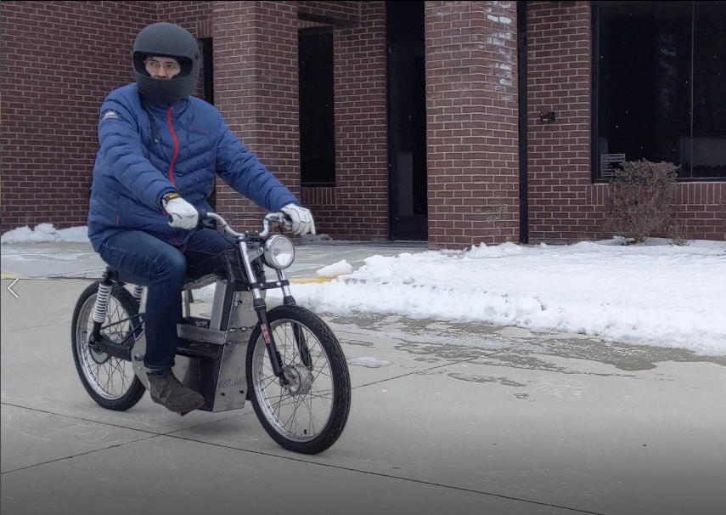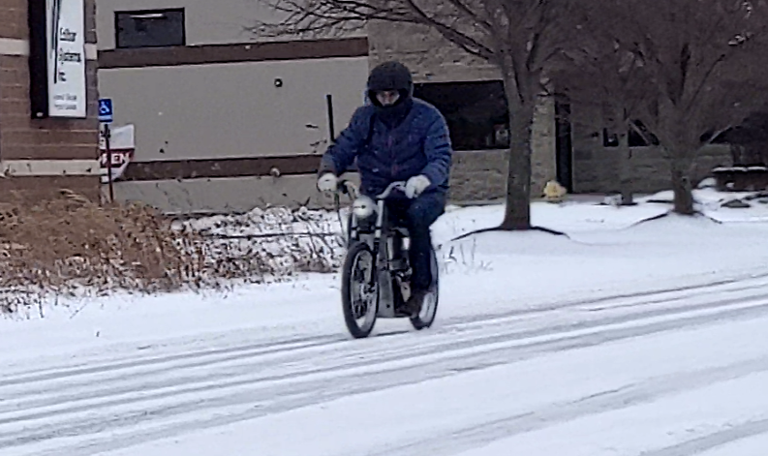

**Fig. 6.2** Testing the motorcycle

## 6.2 Total Weight

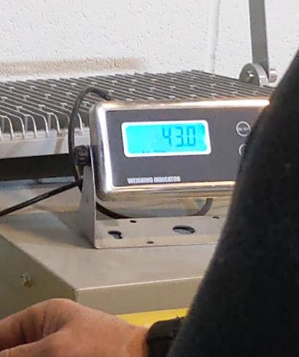 In a bit of a finale to end the testing phase, I decided to weigh the full bike. The total weight is 43kg or 94lbs. It is a bit lighter than the original JC Penney pinto (105lbs) as well as has 3x the power and double the top speed. Unfortunately, I didn’t weigh the bike before I added all the aluminum reinforcement, although I can assume that without the aluminum, I would be another 10lbs lighter.

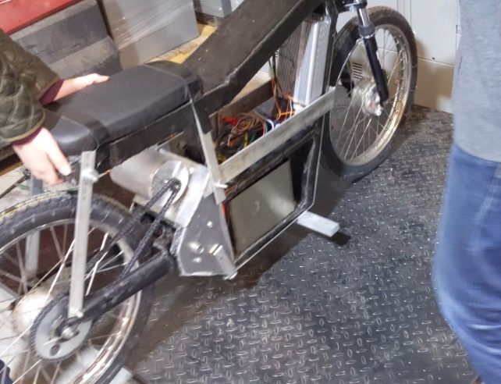**Fig. 4.3.10** Weighing of completed motorcycle

# 7. Conclusion

The conclusion to this project seems to only be the start of a bigger journey. I have learned a lot while building this motorcycle and have many thoughts already of what I’m going to do next time. Modifying this existing frame into something ideal would be difficult. The proper way to go on would be to design something better and build it from scratch once again.

The first thing that needs to be addressed is the position of the motor in relationship to the trailing arm. Most motorcycles have the motor in line with the trailing arm and the chain should be able to clear the trailing arm without touching. I think if I were to use my pre existing trailing arm, I would need to add bigger sprockets on the motor and wheel in order to clear my specific trailing arm. While that is an option, I decided to start my new build by taking inspiration from old frames like Honda CB or CL. They are built out of steel pipes and welded together. The trailing arms are also built from steel pipes and are much thinner than my Pinto trailing arm. This gives the chain a much smaller area to need to clear.

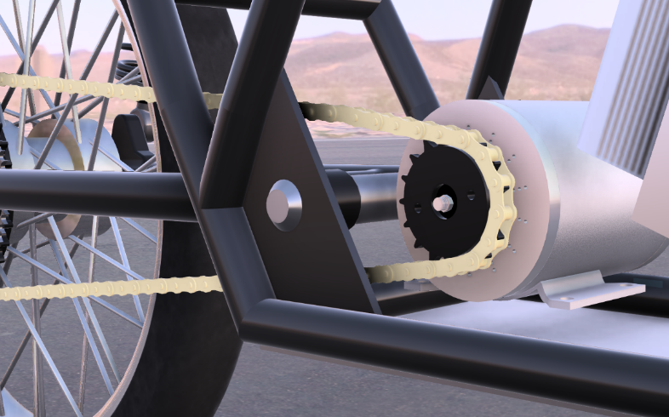

**Fig. 7.1** motor lined up with rear trailing arm

For my next build, I think I would weld a tube frame rather than working with composites like carbon fiber. Because of how lightweight motorcycle frames generally are, I think the added weight would be very minor. Metal pipes are also much easier to work with compared to the added complexity of working with and layering carbon fiber. It is easier to create a strong frame that can handle the forces needed. This is not the end of carbon fiber for me though. I would like to design a new, more complex frame that utilizes carbon fiber as well. By using molds and vacuum forming, it is possible to make very high quality components. Something worth trying would be making carbon fiber wheels for example.

Another thing I did on this new design was to lift the frame higher off the ground. This would address any serious clearance issues, and also make a more natural looking frame for somebody my size. I admit, the old frame did look cool, although it’s almost certain that the bottom would touch the ground if any serious forces acted upon the suspension.

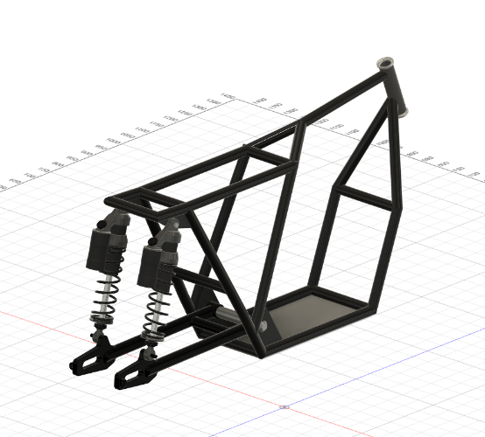**Fig. 7.2** final frame

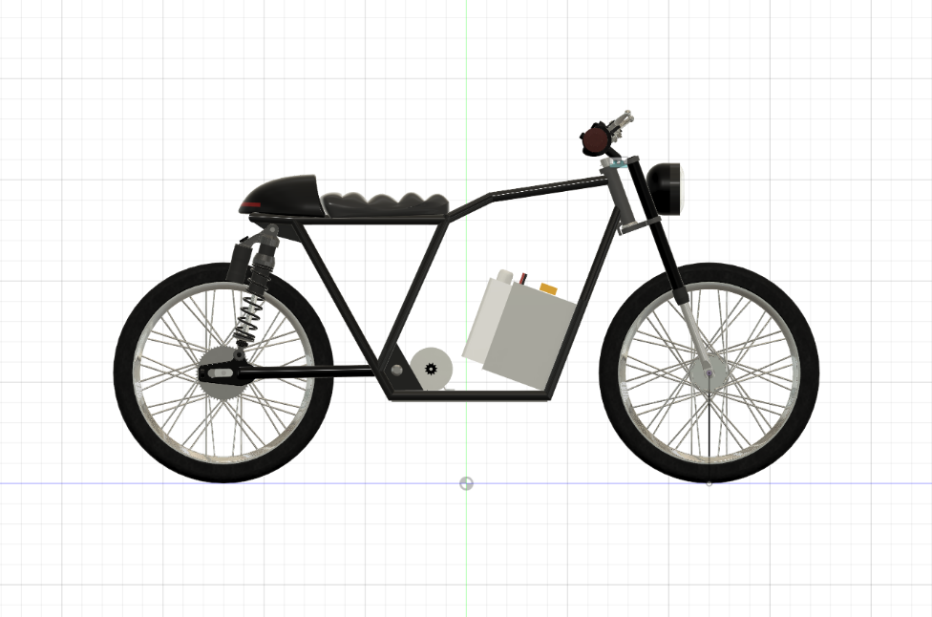

**Fig. 7.3** side view of new assembly

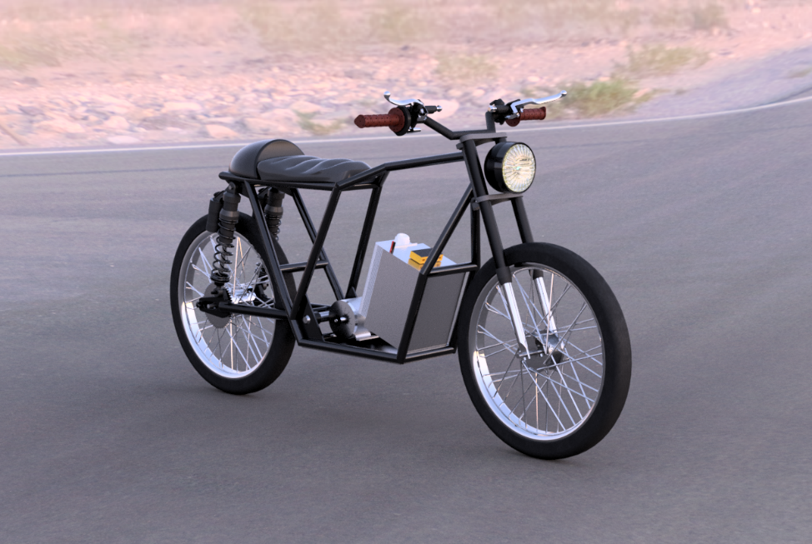**Fig. 7.3** rendering of new motorcycle using „Fusion 360”

Another thing to improve is the total range. I currently have 30 miles or so of range, although I would honestly like to double or triple that. In suburban America, I am faced with much farther commutes than in iasi. Riding to a friends house can be 15 miles only one way. I would barely make it back home, and then spend the rest of the day charging. It’s not very ideal. There is plenty of room for a bigger battery in this frame and now that I have the tools, I can easily make a bigger pack. I could take apart my old battery and probably add 12 more batteries in parallel for a total of 18. This should give me a more useable range of 90 miles (144km).

I have an idea to make a transmission of sorts. I think by adding a more economical gear for cruising at top speed I could greatly benefit and extend my range. I would keep my current gear ratio for accelerating and reaching top speed, although I would add a gear which can keep the bike at top speed with the motor running at a smaller RPM. It would be interesting to try using transmissions like a variable speed pulley, or planetary gears.

The pursuit to improve is something which never stops. I think this project could last a lifetime if I wanted it to. For now, I just plan on making something rideable and useable in day to day life. Thank you for reading my project, and I hope you have gained invaluable information from my project and the mistakes made along the way.

# 8. Bibliography

Timeline: History of the Electric Car

https://www.energy.gov/timeline/timeline-history-electric-car

Types of Motors used in Electric Vehicles

<https://circuitdigest.com/article/different-types-of-motors-used-in-electric-vehicles-ev>

Batteries for Hybrid and Plug-In Electric Vehicles

<https://afdc.energy.gov/vehicles/electric_batteries.html>

Ebike Parts Explained - Getting Started

<https://ebikes.ca/getting-started/ebikes-parts-explained.html>

Don't Ignore the Humble Brushed DC Motor

<https://www.mouser.cn/applications/dont-ignore-the-brushed-dc-motor/>

Motorcycle Frame: Types, Design & Construction

CarBikeTech

<https://carbiketech.com/motorcycle-frame/>

Toshiba Battery school

<https://www.global.toshiba/ww/products-solutions/battery/scib/product/module/sip/download/batteryschool/episode1.html>

Watt Hours; Calculating E-bike Range

<https://www.electricbike.com/watt-hours/>

# 9. ANNEX

